**REALESTATE**

**MANAGEMENT SYSTEM**

*Project Report Submitted By*

# AMEENA SHERIN.V Reg. No: AJC20MCA-2012

*In Partial fulfillment for the Award of the Degree Of*

**REGULAR MASTER OF COMPUTER APPLICATIONS**

# (INMCA) APJ ABDUL KALAM TECHNOLOGICAL UNIVERSITY



# AMAL JYOTHI COLLEGE OF ENGINEERING KANJIRAPPALLY

[Affiliated to APJ Abdul Kalam Technological University, Kerala. Approved by AICTE,

Accredited by NAAC with ‘A’ grade. Koovappally, Kanjirappally, Kottayam, Kerala – 686518]

# 2021-2022

## DEPARTMENT OF COMPUTER APPLICATIONS

### AMAL JYOTHI COLLEGE OF ENGINEERING

**KANJIRAPPALLY**



**CERTIFICATE**

This is to certify that the Project report, “**REALESTATE MANAGEMENT SYSTEM”** is the bonafide work of **AMEENA SHERIN.V (Reg.No:AJC20MCA-2012)** in partial fulfillment of the requirements for the award of the Degree of Integrated Master of Computer Applications under APJ Abdul Kalam Technological University during the year 2021-22.

**Ms. Ankitha Philip Rev.Fr.Dr.Rubin Thottupurathu Jose Internal Guide Coordinator**

**Rev.Fr.Dr.Rubin Thottupurathu Jose**

**Head of the Department**

## DECLARATION

I hereby declare that the project report **“REALESTATE MANAGEMENT SYSTEM”** is a bonafided work done at Amal Jyothi College of Engineering, towards the partial fulfilment of the requirements for the award of the Degree of Regular Master of Computer Applications (MCA) from APJ Abdul Kalam Technological University, during the academic year 2021-2022.

|  |  |
| --- | --- |
| **Date:** | **AMEENA SHERIN.V** |
| **KANJIRAPPALLY** | **Reg.No:AJC20MCA-2012** |

## ACKNOWLEDGEMENT

First and foremost, I thank God almighty for his eternal love and protection throughout the project. I take this opportunity to express my gratitude to all who helped me in completing this project successfully. It has been said that gratitude is the memory of the heart. I wish to express my sincere gratitude to our manager **Rev. Fr. Dr. Mathew Paikatt** and Principal **Dr. Z V Lakaparampil** for providing good faculty for guidance.

I owe a great depth of gratitude towards our Head of the Department **Rev.Fr.Dr. Rubin Thottupurathu Jose** for helping us. I extend my whole hearted thanks to the project coordinators **Rev.Fr.Dr. Rubin Thottupurathu Jose** and **Ms**. **Sona Maria Sebastian** for their valuable suggestions and for overwhelming concern and guidance from the beginning to the end of the project. I would also like to express sincere gratitude to my guide**, Ms. Ankitha Philip** for her inspiration and helping hand.

I thank our beloved teachers for their cooperation and suggestions that helped me throughout the project. I express my thanks to all my friends and classmates for their interest, dedication, and encouragement shown towards the project. I convey my hearty thanks to my family for the moral support, suggestions, and encouragement to make this venture a success.

AMEENA SHERIN.V

## ABSTRACT

Real Estate Management System – is an Estate Agent and Property Management System is a user friendly contact and property manager for real estate professionals. Save time and sell more by empowering to easily keep track of leads, manage listings, and market to new prospects.

Real Estate Management System is complete end to end solution to cover all aspects of Estate Agent’s day to day activity and Property buying selling procedure for small and large organization.

The main aim of this project is to bring the real estate industry online and enabling real estate industry participants to benefit from the Internet. Site acts as an interface between Individuals, brokers and realtors. Here the user can advertise his property for buying or for selling. Site provides online real-estate service committed to helping you make wise and profitable decisions related to buying and selling of properties, in India. We will provide a fresh new approach to our esteemed users to search for properties to buy or rent, and list their properties for selling or leasing. Property promises to be the most preferred way of finding your dream property and we are committed to help you make a wiser property decision, as a buyer or a seller. We understand the needs and concerns of Individuals, Brokers and Builders and provide them a common platform for realizing maximum benefits and security from real-estates. Enter your search criteria and click the SEARCH button to display the matching property. When you click the search button the property advertised will be shown. Provide a superior real-estate experience by making it easier, faster, secure and more accurate to find buyers for your valuable property. We give our customers ease to use and also we will maintain a good relationship with the customers, brokers, sellers for properties.

# CONTENT

|  |  |  |
| --- | --- | --- |
| **Sl. No** | **Topic** | **Page No** |
| **1** | **INTRODUCTION** | **1** |
| **1.1** | **PROJECT OVERVIEW** | **2** |
| **1.2** | **PROJECT SPECIFICATION** | **2** |
| **2** | **SYSTEM STUDY** | **4** |
| **2.1** | **INTRODUCTION** | **5** |
| **2.2** | **EXISTING SYSTEM** | **6** |
| **2.3** | **DRAWBACKS OF EXISTING SYSTEM** | **6** |
| **2.4** | **PROPOSED SYSTEM** | **6** |
| **2.5** | **ADVANTAGES OF PROPOSED SYSTEM** | **7** |
| **3** | **REQUIREMENT ANALYSIS** | **9** |
| **3.1** | **FEASIBILITY STUDY** | **10** |
| **3.1.1** | **ECONOMICAL FEASIBILITY** | **10** |
| **3.1.2** | **TECHNICAL FEASIBILITY** | **11** |
| **3.1.3** | **BEHAVIORAL FEASIBILITY** | **11** |
| **3.2** | **SYSTEM SPECIFICATION** | **12** |
| **3.2.1** | **HARDWARE SPECIFICATION** | **12** |
| **3.2.2** | **SOFTWARE SPECIFICATION** | **12** |
| **3.3** | **SOFTWARE DESCRIPTION** | **12** |
| **3.3.1** | **PHP** | **12** |
| **3.3.2** | **MYSQL** | **13** |
| **4** | **SYSTEM DESIGN** | **15** |
| **4.1** | **INTRODUCTION** | **16** |
| **4.2** | **UML DIAGRAM** | **16** |
| **4.2.1** | **USE CASE DIAGRAM** | **17** |
| **4.2.2** | **SEQUENCE DIAGRAM** | **20** |
| **4.3** | **USER INTERFACE DESIGN** | **29** |
| **4.4** | **DATA BASE DESIGN** | **33** |
| **5** | **SYSTEM TESTING** | **40** |
| **5.1** | **INTRODUCTION** | **41** |
| **5.2** | **TEST PLAN** | **42** |

|  |  |  |
| --- | --- | --- |
| **5.2.1** | **UNIT TESTING** | **42** |
| **5.2.2** | **INTEGRATION TESTING** | **43** |
| **5.2.3** | **VALIDATION TESTING** | **43** |
| **5.2.4** | **USER ACCEPTANCE TESTING** | **43** |
| **6** | **IMPLEMENTATION** | **45** |
| **6.1** | **INTRODUCTION** | **46** |
| **6.2** | **IMPLEMENTATION PROCEDURE** | **47** |
| **6.2.1** | **USER TRAINING** | **47** |
| **6.2.2** | **TRAINING ON APPLICATION SOFTWARE** | **47** |
| **6.2.3** | **SYSTEM MAINTENANCE** | **47** |
| **7** | **CONCLUSION & FUTURE SCOPE** | **48** |
| **7.1** | **CONCLUSION** | **49** |
| **7.2** | **FUTURE SCOPE** | **50** |
| **8** | **BIBLIOGRAPHY** | **51** |
| **9** | **APPENDIX** | **52** |
| **9.1** | **SAMPLE CODE** | **53** |
| **9.2** | **SCREEN SHOTS** | **71** |

## List of Abbreviation

|  |  |  |
| --- | --- | --- |
| IDE | - | Integrated Development Environment |
| HTML | - | Hyper Text Markup Language. |
| CSS | - | Cascading Style Sheet |
| SQL | - | Structured Query Language |
| UML | - | Unified Modeling Language |

## CHAPTER 1 INTRODUCTION

### 1.1 PROJECT OVERVIEW

Real Estate Management System – is an Estate Agent and Property Management System is a user friendly contact and property manager for real estate professionals. The user can also reduce the time and effort in searching properties by using this system. Brokers can easily find properties and also Owners can easily find best buyers. The proposed system includes four users they are admin, User, Broker and Owner. Registered Owner and Broker can login to the site and can upload property details he wants to sale and can also make about the customer through online. The Owner and Broker can also access the enquiries from customer through “Received Enquiry” option. Customer can see the property details that are updated by the Owner and Broker, he can enquiry the property and then the seller directly contact. The admin has the central control over the whole system. He can add and update the options like country, state, city, property type and view the details of the users.

### 1.2 PROJECT SPECIFICATION

The Real Estate Management System is designed in order to eliminate the problem of the current system. This accessibility of the information will be a great advantage as it reduced effort. The system handles all aspects of viewing and enquiry about the property. It allows the seller to post the property,.

The system includes 4 modules. They are:

1. Admin Module
2. User Module
3. Property Owner
4. Broker
5. Buyer(Simple user)

#### 1. Admin Module

1. Dashboard: In this section, admin can see all detail in brief like total property type, total country, total state, total city, total agent, total owner, total buyer(user) ant total property listed.
2. Property Type: In this section, admin can manage property type (add/update).
3. Country: In this section, admin can manage country (add/update).
4. State: In this section, admin can manage state (add/update).
5. City: In this section, admin can manage city (add/update).
6. Owner: In this section, admin can view the detail of owners.
7. Agents: In this section, admin can view the detail of agents.
8. User: In this section, admin can view the detail of user.

Admin can also update his profile, change the password and recover the password.

**User Module**

1. **Property Owner**
2. **Home Page:** Owner can view the home page of real estate management system
3. **Properties:** Owner can view properties they can view property type wise and city wise.
4. **Contact us:** Owner can view contact us page.
5. **My Account:** In this there is three section:
6. **User Profile**

In this section owner do the following activity

**i. Edit Profile:** Owner can edit his/her own profile.

**ii. Change Password:** Owner can change his/her own password.

**Iii.Add Property:** Owner can add his/her own property.

**v. Received Enquiries:** Owner can view receive enquiries against his/her own listed properties and also answer the enquiries.

**vi. Logout:** Owner can logout from own account.

**b. Agents**

1. **Home Page:** Agents can view the home page of real estate management system.
2. **Properties:** Agents can view properties they can view property type wise, Status wise and city wise.
3. **Contact us:** Agents can view contact us page.
4. My Account: In this there is three section:
5. **User Profile**

In this section Agents do the following activity

**I.Edit Profile:** Agents can edit his/her own profile.

**ii.Add Property:** Agents can add his/her own property.

**iii.Received Enquiries:** Agents can view receive enquiries against his/her own listed properties and also answer the enquiries.

**iv.Logout:** Agents can logout from own account.

**c. Logout:** Agents can logout from own account.

**c.Buyer(simple user)**

1. **Home Page:** User can view the home page of real estate management system
2. **Properties:** User can view properties they can view property type wise and city wise and put his/her enquiries against any property
3. **Contact us:** User can view contact us page.
4. **My Account:** In this there is three section:

**a. User Profile**

In this section Agents do the following activity

**I.Edit Profile:** Agents can edit his/her own profile.

**ii.Logout:** Agents can logout from own account.

.

**CHAPTER 2**

**SYSTEM STUDY**

### 2.1 INTRODUCTION

Real Estate Management System – is an Estate Agent and Property Management System is a user friendly contact and property manager for real estate professionals. Save time and sell more by empowering to easily keep track of leads, manage listings, and market to new prospects.

The real of World Wide Web have spread across millions of household, so naturally, Internet has become by far the best platform for real estate marketing today.

Now a days when everything is online, how is it possible that real estate left web application behind? There are lots of real estate companies who advertise their property online so idea behind developing this application is that their property can also sell, or buy property using this. These applications are not widely popular but in future, they have large scope of growth.

This website is an online real estate management through which individual agents or buyer can maintain their property document keeping and managing property registration and also access its information and adding its tasks

Preliminary study is the process of gathering and interpreting facts, using the information for further studies on the system. Preliminary study is problem solving activity that requires intensive communication between the system users and system developers. It does various feasibility studies. In these studies, a rough figure of the system activities can be obtained, from which the decision about the strategies to be followed for effective system study and analysis can be taken.

### 2.2 EXISTING SYSTEM

Existing system is not a fully automated system. Customer can register and they can upload their projects. Each customer can create their own profile .The proposed system rectify the drawbacks of the present system.

It is necessary to modify the existing system in order to include additional information and make the system efficient, flexible and secure. Using the new system customers can upload their project to contractors by viewing the profile details, year of experience etc. of the contractors and contractors can find best labours based on their labour categories.

### 2.3 DRAWBACKS OF EXISTING SYSTEM

* Less convenient in managing project details including plan approval, less transparency, no standardized packages.
* Project often delayed with no progress visibility.
* Unskilled labour force and unmonitored quality of material and not all technology based.
* Human effort is needed.
* Customers do not get a chance to identify the quality of materials used

### 2.4 PROPOSED SYSTEM

The proposed system is defined to meets all the disadvantages of the existing system. It is necessary to have a system that is more user friendly and user attractive for business growth; on such consideration the system is proposed. In our proposed system there is admin who can view all the contractors, labours and customers. It allows customers to upload their projects and do their transactions by using online payment method .Users of this proposed system are admin, customer, contractor and labour. The aim of proposed system is to develop a system of improved facilities. The system provides proper security and reduces the manual work. Our website is multifunctional which includes customer introduction, contractor introduction, project details etc.

The master file that is file which contains all the details of the data’s which are kept for long time is contractor master and customer master. The contractor master contains all the details of completed projects, on-going projects, rates and details of different categories of house, daily progress report, payment options etc. The customer master contains personal details of the customer like customer id, customer name, profession, residential address, etc. This system is designed to help the customers to make the construction easy. The proposed system provides consistency of data and reduces the paper work. Also, the customer can easily select the contractor based on the rating of contractors performance. This helps the customer to fulfill his dream project construction with the help of a contractor through online. This system helps the customer to get its project done smoothly, efficiently and in less time and it helps the contractor to increase the work and income source. This system is made to help both the customer and the contractor.

### 2.5 ADVANTAGES OF PROPOSED SYSTEM

The system is very simple in design and to implement. The system requires very low system resources and the system will work in almost all configurations. It has got following features:

### ➢ You are able to get creative and innovative project plans:-

Our customers will get creative project plans with affordable price and they have the option to view contractor profile and can send feedbacks. Also contractors can able to do proper contruction management and can also improve and increase their work and income source.

### ➢ Better security: -

For data to remain secure measures must be taken to prevent unauthorized access. Security means that data are protected from various forms of destruction. The system security problem can be divided into four related issues: security, integrity, privacy and confidentiality. Username and password requirement to sign in ensures security. It will also provide data security as we are using the secured databases for maintaining the documents.

### ➢ Ensure data accuracy: -

The proposed system eliminates the manual errors while entering the details of the users during the registration.

### ➢ Better service: -

The system will avoid the burden of hard copy storage. We can also conserve the time and human resources for doing the same task. The data can be maintained for longer period with no loss of data.

## CHAPTER 3

**REQUIREMENT ANALYSIS**

### 3.1 FEASIBILITY STUDY

Feasibility study is made to see if the project on completion will serve the purpose of the organization for the amount of work, effort and the time that spend on it. Feasibility study lets the developer foresee the future of the project and the usefulness. A feasibility study of a system proposal is according to its workability, which is the impact on the organization, ability to meet their user needs and effective use of resources. Thus, when a new application is proposed it normally goes through a feasibility study before it is approved for development.

The document provides the feasibility of the project that is being designed and lists various areas that were considered very carefully during the feasibility study of this project such as Technical, Economic and Operational feasibilities. The following are its features: -

#### 3.1.1 Economical Feasibility

The developing system must be justified by cost and benefit. Criteria to ensure that effort is concentrated on project, which will give best, return at the earliest. One of the factors, which affect the development of a new system, is the cost it would require.

The following are some of the important financial questions asked during preliminary investigation:

* The costs conduct a full system investigation.
* The cost of the hardware and software.
* The benefits in the form of reduced costs or fewer costly errors.

The proposed system is developed as part of project work, there is no manual cost to spend for the proposed system. Also all the resources are already available, it give an indication of the system is economically possible for development.

The cost of project, BUILDTECH CONSTRUCTION MANAGEMENT SYSTEM was divided according to the system used, its development cost and cost for hosting the project. According to all the calculations the project was developed in a low cost. As it is completely developed using open source software.

#### 3.1.2 Technical Feasibility

The system must be evaluated from the technical point of view first. The assessment of this feasibility must be based on an outline design of the system requirement in the terms of input, output, programs and procedures. Having identified an outline system, the investigation must go on to suggest the type of equipment, required method developing the system, of running the system once it has been designed. Technical issues raised during the investigation are:

* Does the existing technology sufficient for the suggested one?
* Can the system expand if developed?

The project should be developed such that the necessary functions and performance are achieved within the constraints. The project requires High Resolution Scanning device and utilizes Cryptographic techniques. Through the technology may become obsolete after some period of time, due to the fact that newer version of same software supports older versions, the system may still be used. So there are minimal constraints involved with this project. The system has been developed using PHP in front end and MySQL in server in back end, the project is technically feasible for development. The system has been developed using PHP in front end and MySQL in server in back end, the project is technically feasible for development. The System used was also of good performance of

Processor Intel i3 core; RAM 4GB and, Hard disk 1TB

**3.1.3 Behavioral Feasibility** The proposed system includes the following questions:

* Is there sufficient support for the users?
* Will the proposed system cause harm?

The project would be beneficial because it satisfies the objectives when developed and installed. All behavioral aspects are considered carefully and conclude that the project is behaviorally feasible.

BUILDTECH CONSTRUCTION MANAGEMENT SYSTEM, GUI is simple so that users can easily use it. BUILDTECH CONSTRUCTION MANAGEMENT SYSTEM is simple enough so that no training is needed.

### 3.2 SYSTEM SPECIFICATION

#### 3.2.1 Hardware Specification

Processor - Intel core i3 RAM - 4 GB

Hard disk - 1 TB

#### 3.2.2 Software Specification

|  |  |
| --- | --- |
| Front End - | HTML, CSS |
| Backend - | MYSQL |
| Client on PC - | Windows 7 and above. |

Technologies used - JS, HTML5, AJAX, J Query, PHP, CSS

### 3.3 SOFTWARE DESCRIPTION

#### 3.3.1 PHP

PHP is a server side scripting language designed for web development but also used as a general purpose programming language. PHP is now installed on more than 244 million websites and 2.1 million web servers. Originally created by Rasmus Ledorf in 1995, the reference implementation of PHP is now produced by the PHP group. While PHP originally stood for personal Home page ,it now stands for

PHP:HypertextPreprocessor, a recursive acronym.PHP code is interpreted by a web server with a PHP processor module which generates the resulting web page.PHP commands can be embedded directly into a HTML source document rather than calling an external file to process data. It has also evolved to include a command-line interface capability and can be used in standalone incompatible with the GNU General Public License (GPL) due to restrictions on the usage of the term PHP.PHP can be deployed on most web servers and also as a standalone shell on almost every operating system and platform, free of charge.

##### 3.3.2 MySQL

MySQL, the most popular Open Source SQL database management system, is developed, distributed, and supported by Oracle Corporation. The MySQL Web site provides the latest information about MySQL software.

* **MySQL is a database management system.** 
  1. database is a structured collection of data. It may be anything from a simple shopping list to a picture gallery or the vast amounts of information in a corporate network. To add, access, and process data stored in a computer database, you need a database management system such as MySQL Server. Since computers are very good at handling large amounts of data, database management systems play a central role in computing, as standalone utilities, or as parts of other applications.
* **MySQL databases are relational.** 
  1. relational database stores data in separate tables rather than putting all the data in one big storeroom. The database structures are organized into physical files optimized for speed. The logical model, with objects such as databases, tables, views, rows, and columns, offers a flexible programming environment. You set up rules governing the relationships between different data fields, such as one-to-one, one-to-many, unique, required or optional, and “pointers” between different tables. The database enforces these rules, so that with a well-designed database, your application never sees inconsistent, duplicate, orphan, out-of-date, or missing data.

The SQL part of “MySQL” stands for “Structured Query Language”. SQL is the most common standardized language used to access databases. Depending on your programming environment, you might enter SQL directly (for example, to generate reports), embed SQL statements into code written in another language, or use a language-specific API that hides the SQL syntax. SQL is defined by the ANSI/ISO SQL Standard. The SQL standard has been evolving since 1986 and several versions exist. In this manual, “SQL92” refers to the standard released in 1992,

“SQL: 1999” refers to the standard released in 1999, and “SQL: 2003” refers to the current version of the standard. We use the phrase “the SQL standard” to mean the current version of the SQL Standard at any time.

* **MySQL software is Open Source*.***

Open Source means that it is possible for anyone to use and modify the software. Anybody can download the MySQL software from the Internet and use it without paying anything. If you wish, you may study the source code and change it to suit your needs. The MySQL software uses the GPL (GNU General Public License), to define what you may and may not do with the software in different situations. If you feel uncomfortable with the GPL or need to embed MySQL code into a commercial application, you can buy a commercially licensed version from us. See the MySQL Licensing Overview for more information.

* **The MySQL Database Server is very fast, reliable, scalable, and easy to use.** If that is what you are looking for, you should give it a try. MySQL Server can run comfortably on a desktop or laptop, alongside your other applications, web servers, and so on, requiring little or no attention. If you dedicate an entire machine to MySQL, you can adjust the settings to take advantage of all the memory, CPU power, and I/O capacity available.
* **MySQL Server works in client/server or embedded systems*.***

The MySQL Database Software is a client/server system that consists of a multithreaded SQL server that supports different backends, several different client programs and libraries, administrative tools, and a wide range of application programming interfaces (APIs). We also provide MySQL Server as an embedded multi-threaded library that you can link into your application to get a smaller, faster, easier-to-manage standalone product.

**CHAPTER 4**

**SYSTEM DESIGN**

## 4.1 INTRODUCTION

Design is the first step into the development phase for any engineered product or system. Design is a creative process. A good design is the key to effective system. The term “design” is defined as “the process of applying various techniques and principles for the purpose of defining a process or a system in sufficient detail to permit its physical realization”. It may be defined as a process of applying various techniques and principles for the purpose of defining a device, a process or a system in sufficient detail to permit its physical realization. Software design sits at the technical kernel of the software engineering process and is applied regardless of the development paradigm that is used. The system design develops the architectural detail required to build a system or product. As in the case of any systematic approach, this software too has undergone the best possible design phase fine tuning all efficiency, performance and accuracy levels. The design phase is a transition from a user oriented document to a document to the programmers or database personnel. System design goes through two phases of development: Logical and Physical Design.

### 4.2 UML DIAGRAM

UML is a standard language for specifying, visualizing, constructing, and documenting the artifacts of software systems. UML was created by the Object Management Group (OMG) and UML 1.0 specification draft was proposed to the OMG in January 1997.

UML stands for **Unified Modeling Language**. UML is different from the other common programming languages such as C++, Java, COBOL, etc. UML is a pictorial language used to make software blueprints. UML can be described as a general purpose visual modeling language to visualize, specify, construct, and document software system. Although UML is generally used to model software systems, it is not limited within this boundary. It is also used to model non-software systems as well. For example, the process flow in a manufacturing unit, etc. UML is not a programming language but tools can be used to generate code in various languages using UML diagrams. UML has a direct relation with object oriented analysis and design. After some standardization, UML has become an OMG standard. All the elements, relationships are used to make a complete UML diagram and the diagram represents a system. The visual effect of the UML diagram is the most important part of the entire process. All the other elements are used to make it complete. UML includes the following nine diagrams.

* Class diagram
* Object diagram
* Use case diagram
* Sequence diagram
* Collaboration diagram
* Activity diagram
* Statechart diagram
* Deployment diagram
* Component diagram

#### 4.2.1 USE CASE DIAGRAM

A use case diagram is a graphic depiction of the interactions among the elements of a system. A use case is a methodology used in system analysis to identify, clarify, and organize system requirements. In this context, the term "system" refers to something being developed or operated, such as a mail-order product sales and service Web site. Use case diagrams are employed in UML (Unified Modeling Language), a standard notation for the modeling of real-world objects and systems.

System objectives can include planning overall requirements, validating a hardware design, testing and debugging a software product under development, creating an online help reference, or performing a consumer-serviceoriented task. For example, use cases in a product sales environment would include item ordering, catalog updating, payment processing, and customer relations. A use case diagram contains four components.

* The boundary, which defines the system of interest in relation to the world around it.
* The actors, usually individuals involved with the system defined according to their

roles.

* The use cases, which are the specific roles are played by the actors within and around the system.
* The relationships between and among the actors and the use cases.

Use case diagrams are drawn to capture the functional requirements of a system. After identifying the above items, we have to use the following guidelines to draw an efficient use case diagram

* The name of a use case is very important. The name should be chosen in such a way so that it can identify the functionalities performed.
* Give a suitable name for actors.
* Show relationships and dependencies clearly in the diagram.
* Do not try to include all types of relationships, as the main purpose of the diagram is to identify the requirements.
* Use notes whenever required to clarify some important points.

Fig 1 : Use case diagram for BuildTech Construction Management System

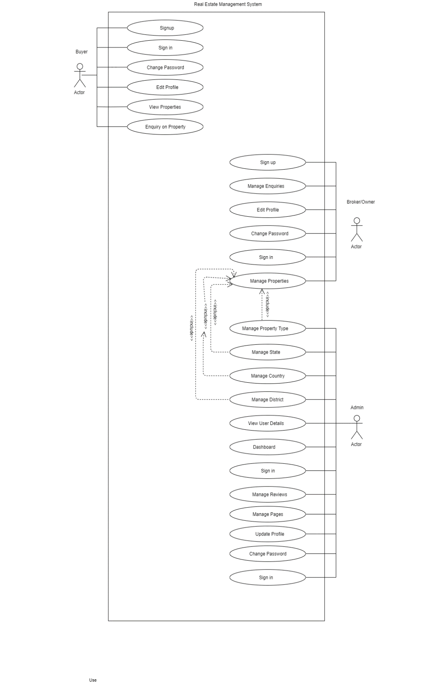

#### 4.2.2 SEQUENCE DIAGRAM

A sequence diagram simply depicts interaction between objects in a sequential order i.e. the order in which these interactions take place. We can also use the terms event diagrams or event scenarios to refer to a sequence diagram. Sequence diagrams describe how and in what order the objects in a system function. These diagrams are widely used by businessmen and software developers to document and understand requirements for new and existing systems.

##### Sequence Diagram Notations –

1. **Actors –** An actor in a UML diagram represents a type of role where it interacts with the system and its objects. It is important to note here that an actor is always outside the scope of the system we aim to model using the UML diagram. We use actors to depict various roles including human users and other external subjects. We represent an actor in a UML diagram using a stick person notation. We can have multiple actors in a sequence diagram.
2. **Lifelines –** A lifeline is a named element which depicts an individual participant in a sequence diagram. So basically each instance in a sequence diagram is represented by a lifeline. Lifeline elements are located at the top in a sequence diagram.
3. **Messages –** Communication between objects is depicted using messages. The messages appear in a sequential order on the lifeline. We represent messages using arrows. Lifelines and messages form the core of a sequence diagram.

Messages can be broadly classified into the following categories:

* + Synchronous messages
  + Asynchronous Messages
  + Create message
  + Delete Message
  + Self-Message
  + Reply Message
  + Found Message
  + Lost Message **iv. Guards –** To model conditions we use guards in UML. They are used when we need to restrict the flow of messages on the pretext of a condition being met. Guards play an important role in letting software developers know the constraints attached to a system or a particular process.

##### Uses of sequence diagrams –

* Used to model and visualize the logic behind a sophisticated function, operation or procedure.
* They are also used to show details of UML use case diagrams.
* Used to understand the detailed functionality of current or future systems.
* Visualise how messages and tasks move between objects or components in a system.

Fig 1 : Sequence diagram for RealEstate Management System

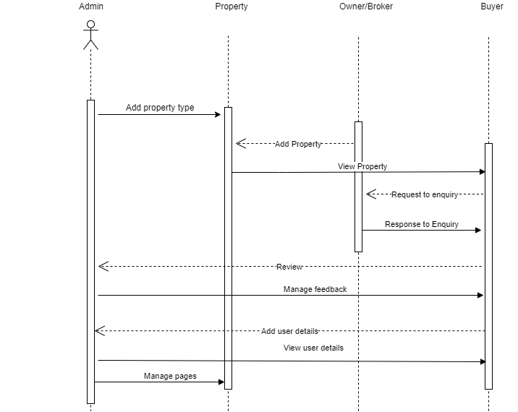

#### 4.2.3 ACTIVITY DIAGRAM

An activity diagram is a behavioral diagram i.e. it depicts the behavior of a system.

An activity diagram portrays the control flow from a start point to a finish point showing the various decision paths that exist while the activity is being executed. We can depict both sequential processing and concurrent processing of activities using an activity diagram. They are used in business and process modelling where their primary use is to depict the dynamic aspects of a system.An activity diagram is very similar to a flowchart.

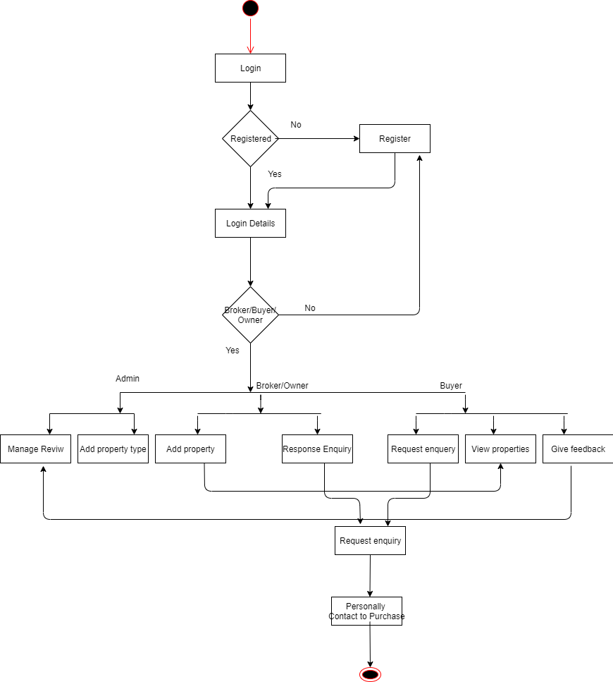

#### 4.2.4 CLASS DIAGRAM

**UML class diagrams:** Class diagrams are the main building blocks of every object-oriented method. The class diagram can be used to show the classes, relationships, interface, association, and collaboration. UML is standardized in class diagrams. Since classes are the building block of an application that is based on OOPs, so as the class diagram has an appropriate structure to represent the classes, inheritance, relationships, and everything that OOPs have in their context. It describes various kinds of objects and the static relationship between them.   
The main purpose to use class diagrams are: 

* This is the only UML that can appropriately depict various aspects of the OOPs concept.
* Proper design and analysis of applications can be faster and efficient.
* It is the base for deployment and component diagram.

There are several software available that can be used online and offline to draw these diagrams Like Edraw max, lucid chart, etc. There are several points to be kept in focus while drawing the class diagram. These can be said as its syntax: 

* Each class is represented by a rectangle having a subdivision of three compartments name, attributes, and operation.
* There are three types of modifiers that are used to decide the visibility of attributes and operations.
  + + is used for public visibility(for everyone)
  + # is used for protected visibility (for friend and derived)
  + – is used for private visibility (for only me)

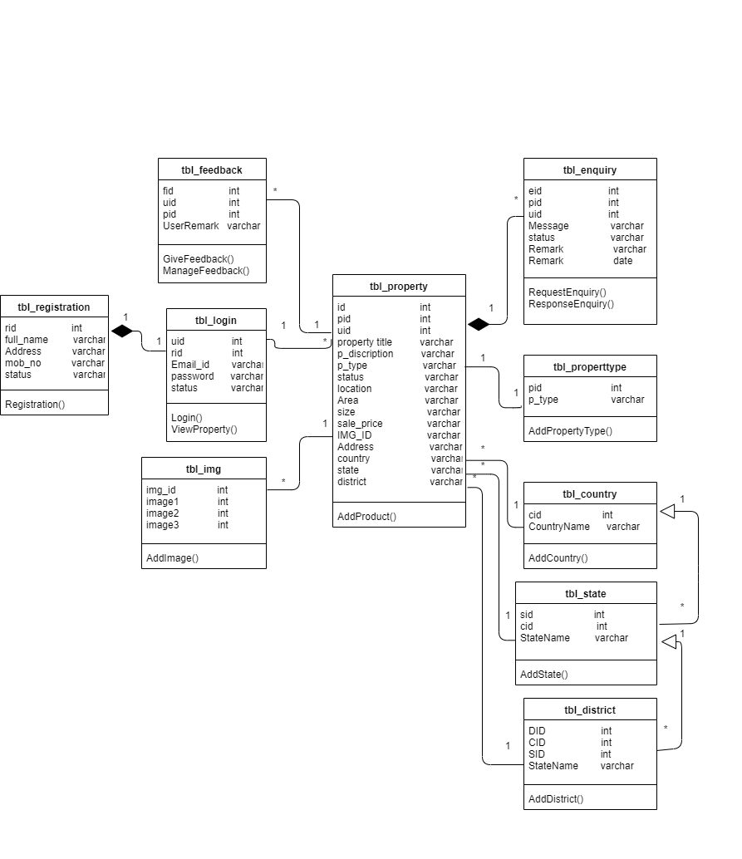

#### 4.2.5 COMPONENT DIAGRAM

A component diagram, also known as a UML component diagram, describes the organization and wiring of the physical components in a system. Component diagrams are often drawn to help model implementation details and double-check that every aspect of the system's required functions is covered by planned development.

#### Component

A component is a logical unit block of the system, a slightly higher abstraction than classes. It is represented as a rectangle with a smaller rectangle in the upper right corner with tabs or the word written above the name of the component to help distinguish it from a class.

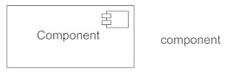

#### Interface

An interface (small circle or semi-circle on a stick) describes a group of operations used (required) or created (provided) by components. A full circle represents an interface created or provided by the component. A semi-circle represents a required interface, like a person's input.

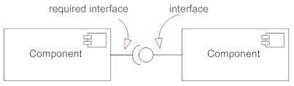

#### Dependencies

Draw dependencies among components using dashed arrows.

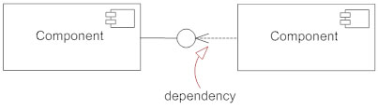

#### Port

Ports are represented using a square along the edge of the system or a component. A port is often used to help expose required and provided interfaces of a component.

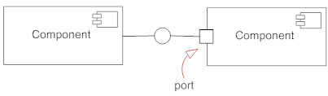

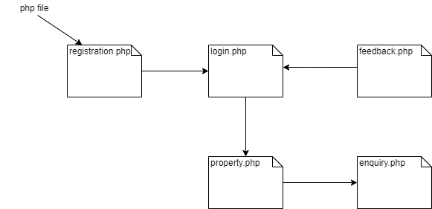

#### 4.2.6OBJECT DIAGRAM

Object diagrams are derived from class diagrams so object diagrams are dependent upon class diagrams.

Object diagrams represent an instance of a class diagram. The basic concepts are similar for class diagrams and object diagrams. Object diagrams also represent the static view of a system but this static view is a snapshot of the system at a particular moment.

Object diagrams are used to render a set of objects and their relationships as an instance.

## Purpose of Object Diagrams

The purpose of a diagram should be understood clearly to implement it practically. The purposes of object diagrams are similar to class diagrams.

The difference is that a class diagram represents an abstract model consisting of classes and their relationships. However, an object diagram represents an instance at a particular moment, which is concrete in nature.

It means the object diagram is closer to the actual system behavior. The purpose is to capture the static view of a system at a particular moment.

The purpose of the object diagram can be summarized as −

* Forward and reverse engineering.
* Object relationships of a system
* Static view of an interaction.
* Understand object behaviour and their relationship from practical perspective

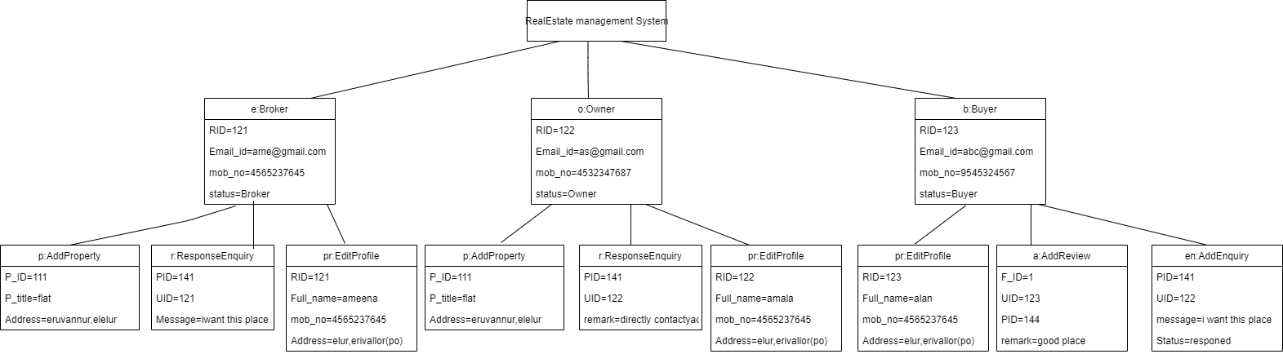

#### STATE DIAGRAM

The name of the diagram itself clarifies the purpose of the diagram and other details. It describes different states of a component in a system. The states are specific to a component/object of a system.

A Statechart diagram describes a state machine. State machine can be defined as a machine which defines different states of an object and these states are controlled by external or internal events.

Activity diagram explained in the next chapter, is a special kind of a Statechart diagram. As Statechart diagram defines the states, it is used to model the lifetime of an object.

## Purpose of Statechart Diagrams

Statechart diagram is one of the five UML diagrams used to model the dynamic nature of a system. They define different states of an object during its lifetime and these states are changed by events. Statechart diagrams are useful to model the reactive systems. Reactive systems can be defined as a system that responds to external or internal events.

Statechart diagram describes the flow of control from one state to another state. States are defined as a condition in which an object exists and it changes when some event is triggered. The most important purpose of Statechart diagram is to model lifetime of an object from creation to termination.

Statechart diagrams are also used for forward and reverse engineering of a system. However, the main purpose is to model the reactive system.

Following are the main purposes of using Statechart diagrams −

* To model the dynamic aspect of a system.
* To model the life time of a reactive system.
* To describe different states of an object during its life time.
* Define a state machine to model the states of an object.

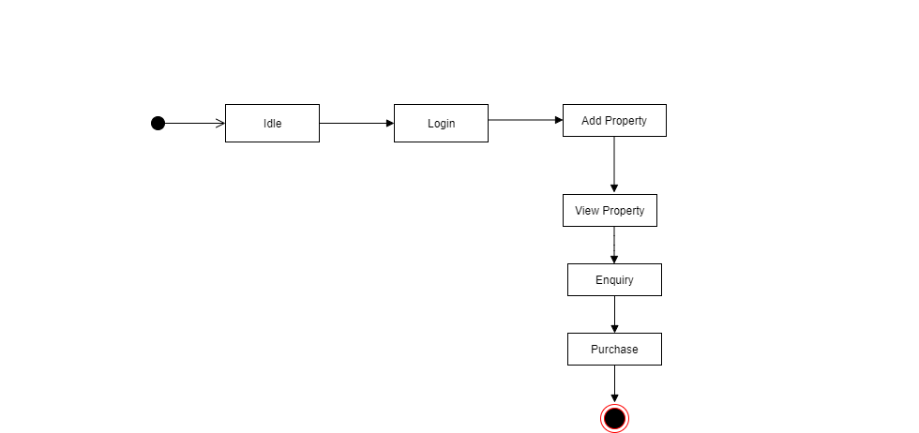

#### DEPLOYMENT DIAGRAM

Deployment diagrams are used to visualize the topology of the physical components of a system, where the software components are deployed.

Deployment diagrams are used to describe the static deployment view of a system. Deployment diagrams consist of nodes and their relationships.

## Purpose of Deployment Diagrams

The term Deployment itself describes the purpose of the diagram. Deployment diagrams are used for describing the hardware components, where software components are deployed. Component diagrams and deployment diagrams are closely related.

Component diagrams are used to describe the components and deployment diagrams shows how they are deployed in hardware.

UML is mainly designed to focus on the software artifacts of a system. However, these two diagrams are special diagrams used to focus on software and hardware components.

Most of the UML diagrams are used to handle logical components but deployment diagrams are made to focus on the hardware topology of a system. Deployment diagrams are used by the system engineers.

The purpose of deployment diagrams can be described as −

* Visualize the hardware topology of a system.
* Describe the hardware components used to deploy software components.
* Describe the runtime processing nodes.

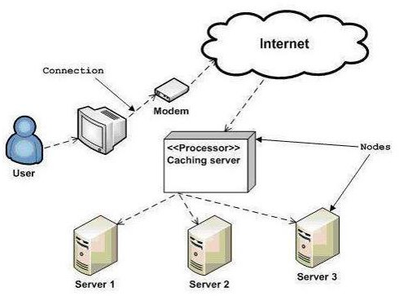

##### 4.3 USER INTERFACE DESIGN

###### 4.3.1-INPUT DESIGN

Form Name : Customer Registration

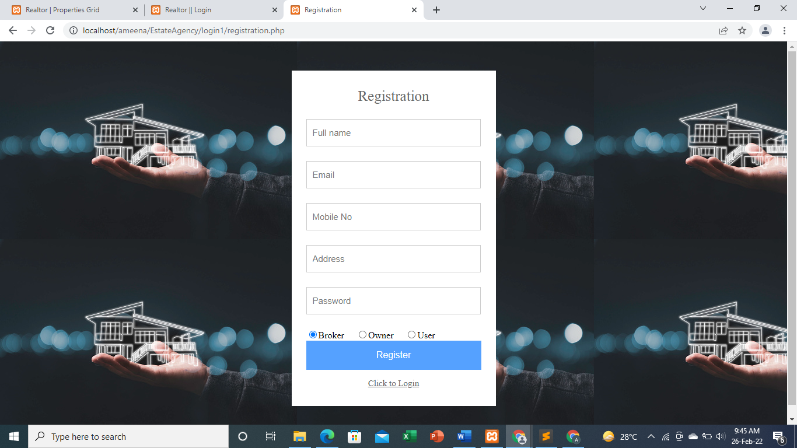

Form Name : Admin Login

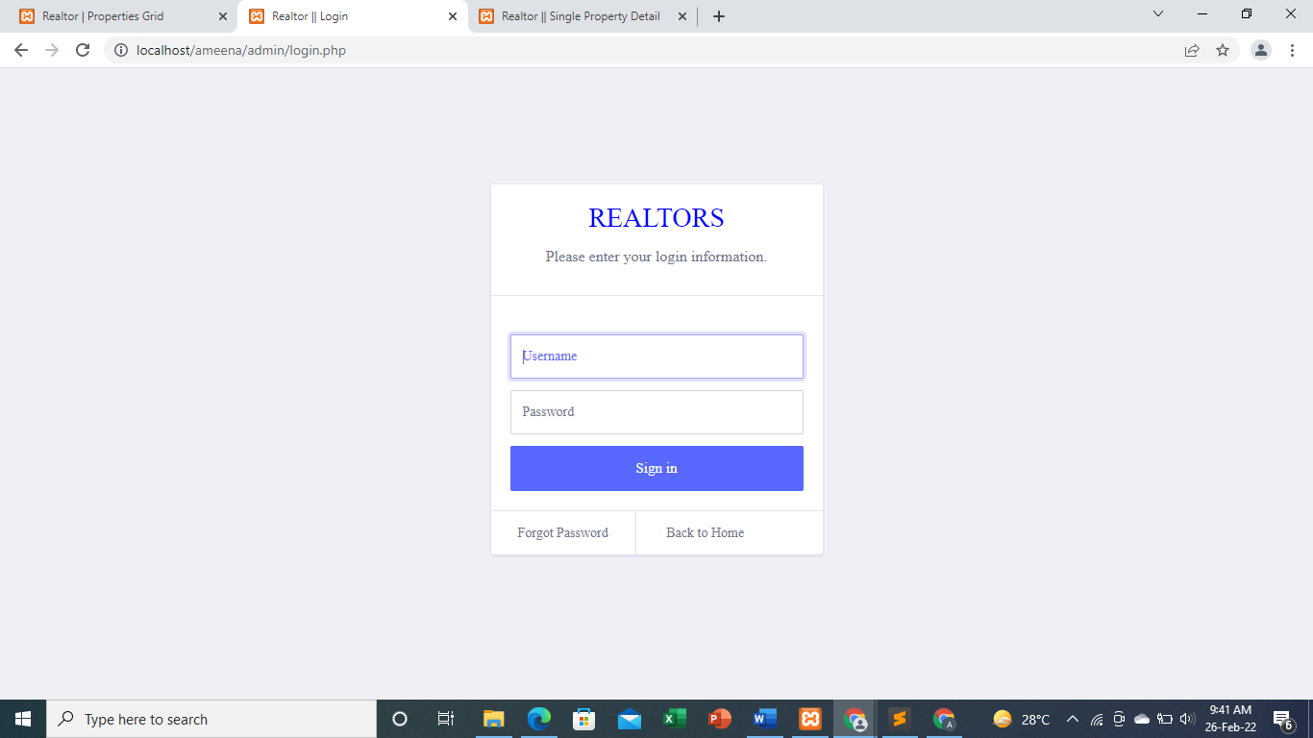

Form Name : User Login

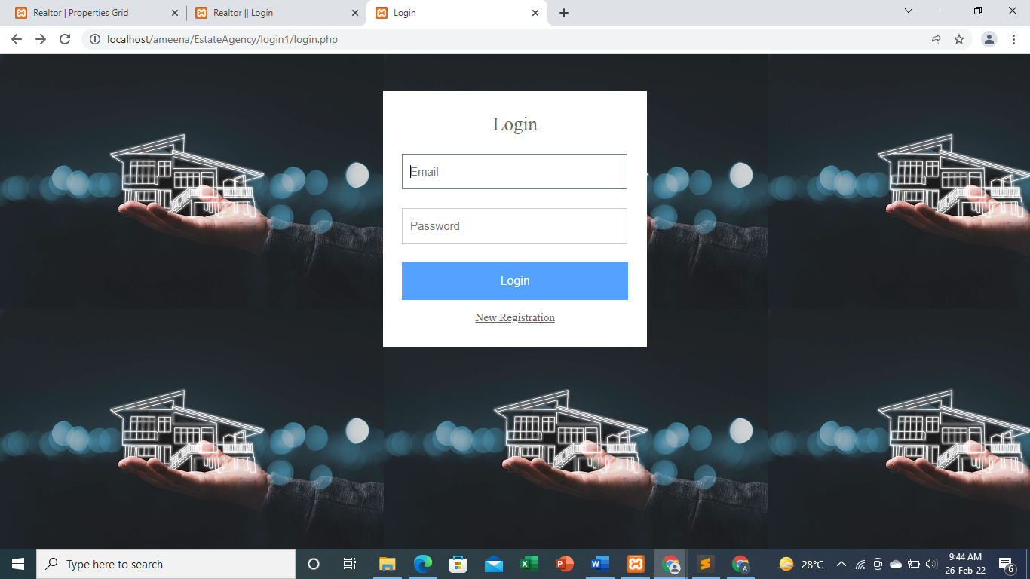

Form Name : Customer Search Contractor

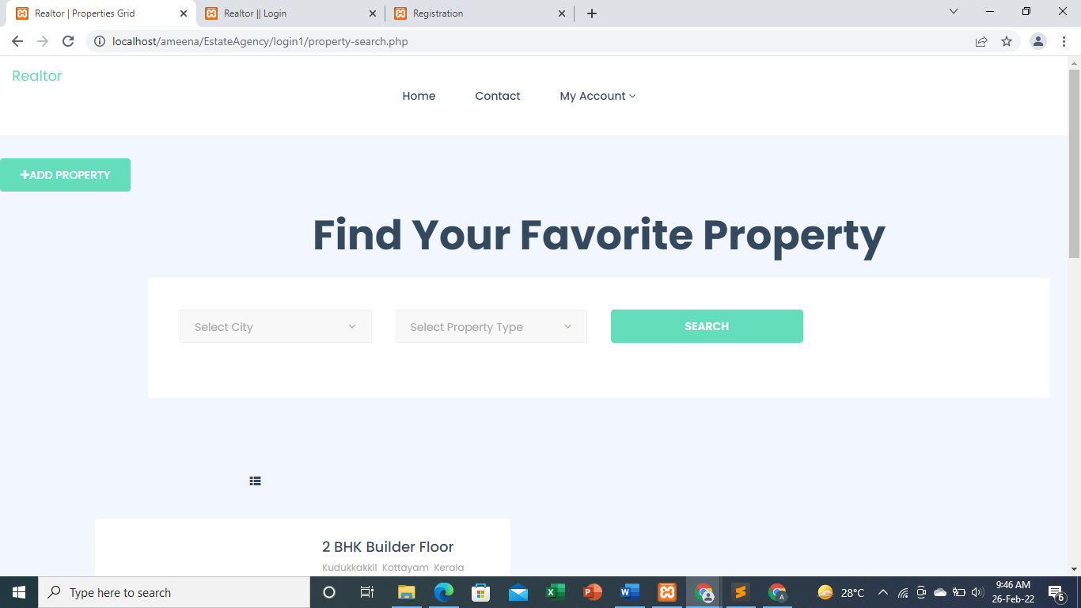

Form Name : Add Property Details

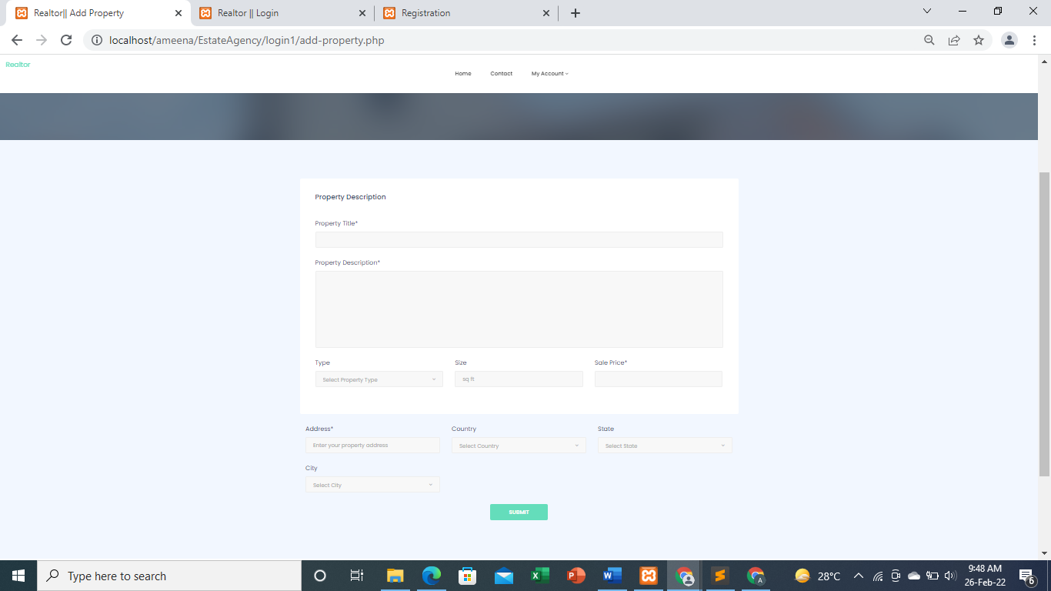

4.3.2 OUTPUT DESIGN

User Login

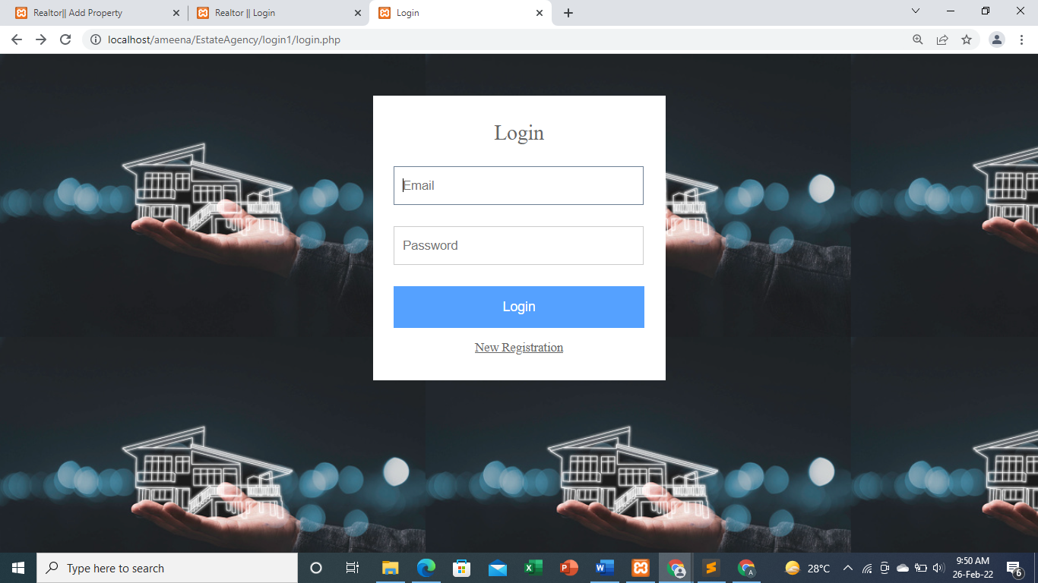

Customer Registration

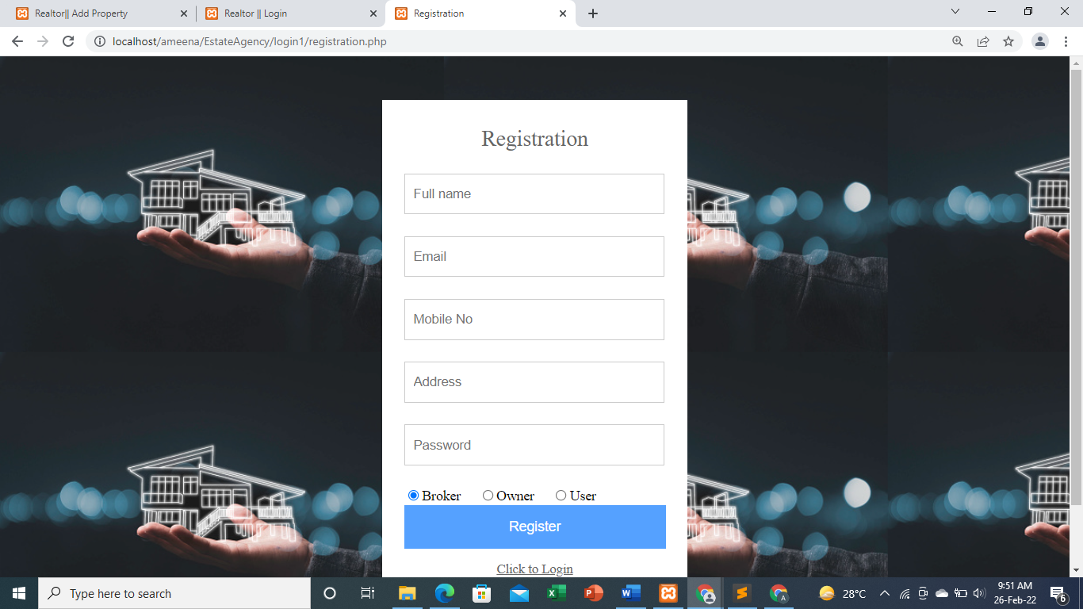

Property Search

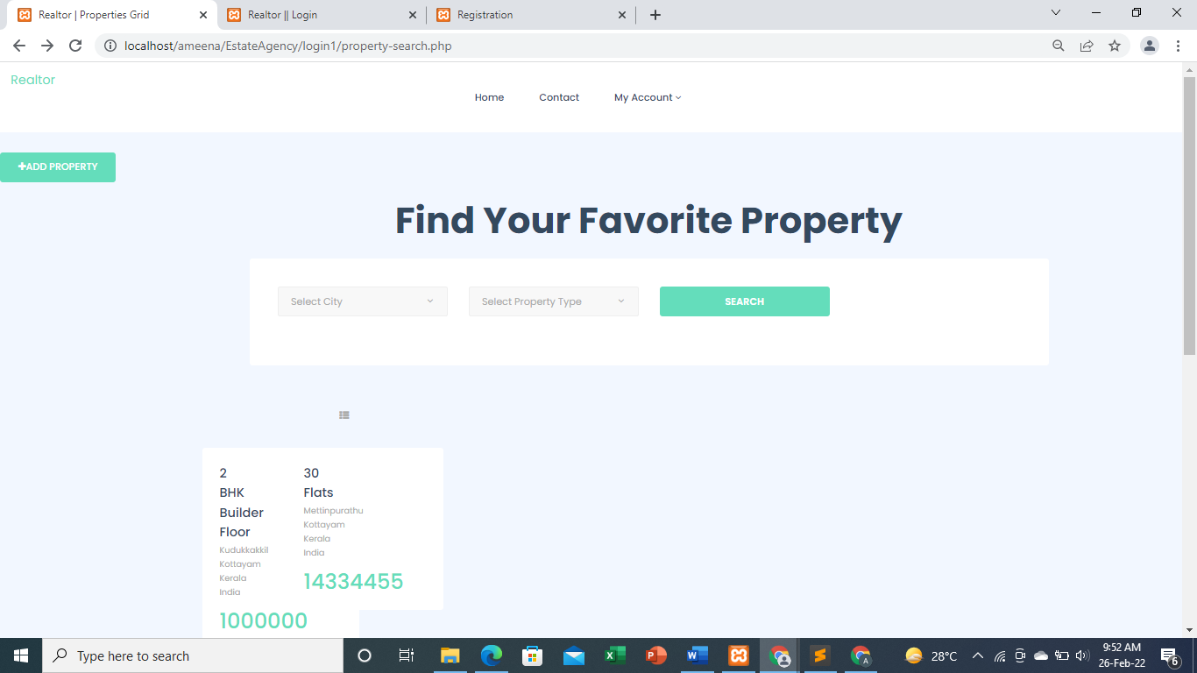

### 4.4 DATABASE DESIGN

A database is an organized mechanism that has the capability of storing information through which a user can retrieve stored information in an effective and efficient manner. The data is the purpose of any database and must be protected.

The database design is a two level process. In the first step, user requirements are gathered together and a database is designed which will meet these requirements as clearly as possible. This step is called Information Level Design and it is taken independent of any individual DBMS.

In the second step, this Information level design is transferred into a design for the specific DBMS that will be used to implement the system in question. This step is called Physical Level Design, concerned with the characteristics of the specific DBMS that will be used. A database design runs parallel with the system design. The organization of the data in the database is aimed to achieve the following two major objectives.

* Data Integrity
* Data independence

#### 4.6.1 Relational Database Management System (RDBMS)

A relational model represents the database as a collection of relations. Each relation resembles a table of values or file of records. In formal relational model terminology, a row is called a tuple, a column header is called an attribute and the table is called a relation. A relational database consists of a collection of tables, each of which is assigned a unique name. A row in a tale represents a set of related values.

#### Relations, Domains & Attributes

A table is a relation. The rows in a table are called tuples. A tuple is an ordered set of n elements. Columns are referred to as attributes. Relationships have been set between every table in the database. This ensures both Referential and Entity Relationship Integrity. A domain D is a set of atomic values. A common method of specifying a domain is to specify a data type from which the data values forming the domain are drawn. It is also useful to specify a name for the domain to help in interpreting its values.

Every value in a relation is atomic, that is not decomposable.

#### Relationships

* Table relationships are established using Key. The two main keys of prime importance are Primary Key & Foreign Key. Entity Integrity and Referential Integrity Relationships can be established with these keys.
* Entity Integrity enforces that no Primary Key can have null values.
* Referential Integrity enforces that no Primary Key can have null values.
* Referential Integrity for each distinct Foreign Key value, there must exist a matching Primary Key value in the same domain. Other key are Super Key and Candidate Keys.

##### 4.6.2 Normalization

Data are grouped together in the simplest way so that later changes can be made with minimum impact on data structures. Normalization is formal process of data structures in manners that eliminates redundancy and promotes integrity. Normalization is a technique of separating redundant fields and breaking up a large table into a smaller one. It is also used to avoid insertion, deletion, and updating anomalies. Normal form in data modelling use two concepts, keys and relationships. A key uniquely identifies a row in a table. There are two types of keys, primary key and foreign key. A primary key is an element or a combination of elements in a table whose purpose is to identify records from the same table. A foreign key is a column in a table that uniquely identifies record from a different table. All the tables have been normalized up to the third normal form.

As the name implies, it denotes putting things in the normal form. The application developer via normalization tries to achieve a sensible organization of data into proper tables and columns and where names can be easily correlated to the data by the user. Normalization eliminates repeating groups at data and thereby avoids data redundancy which proves to be a great burden on the computer resources. These include:

* Normalize the data.
* Choose proper names for the tables and columns.
* Choose the proper name for the data.

#### First Normal Form

The First Normal Form states that the domain of an attribute must include only atomic values and that the value of any attribute in a tuple must be a single value from the domain of that attribute. In other words 1NF disallows “relations within relations” or “relations as attribute values within tuples”. The only attribute values permitted by 1NF are single atomic or indivisible values. The first step is to put the data into First Normal Form. This can be donor by moving data into separate tables where the data is of similar type in each table. Each table is given a Primary Key or Foreign Key as per requirement of the project. In this we form new relations for each non-atomic attribute or nested relation. This eliminated repeating groups of data. A relation is said to be in first normal form if only if it satisfies the constraints that contain the primary key only.

#### Second Normal Form

According to Second Normal Form, for relations where primary key contains multiple attributes, no non-key attribute should be functionally dependent on a part of the primary key. In this we decompose and setup a new relation for each partial key with its dependent attributes. Make sure to keep a relation with the original primary key and any attributes that are fully functionally dependent on it. This step helps in taking out data that is only dependent on a part of the key. A relation is said to be in second normal form if and only if it satisfies all the first normal form conditions for the primary key and every non-primary key attributes of the relation is fully dependent on its primary key alone.

#### Third Normal Form

According to Third Normal Form, Relation should not have a non-key attribute functionally determined by another non-key attribute or by a set of non-key attributes. That is, there should be no transitive dependency on the primary key. In this we decompose and set up relation that includes the non-key attributes that functionally determines other non-key attributes. This step is taken to get rid of anything that does not depend entirely on the Primary Key. A relation is said to be in third normal form if only if it is in second normal form and more over the non key attributes of the relation should not be depend on other non-key attribute.

**TABLE DESIGN**

#### Table No : 01 Table Name : tbl_users

**Primary Key: login_id**

**Foreign Key :**

#### Table Description : To store user Login information

|  |  |  |
| --- | --- | --- |
| Field | Datatype | Constraints |
| ID | int | Primary key |
| Full_name | Varchar(100) | NOT NULL |
| Address | Varchar(500) | NOT NULL |
| Mob no | Int(10) | NOT NULL |
| Status | Varchar(20) | NOT NULL |
| emailed | Varchar(10) | NOT NULL |

#### Table No : 03 Table Name : tblcountry

#### Primary Key : id Foreign Key

#### Table Description: To store country information

|  |  |  |
| --- | --- | --- |
| Field | Datatype | Constraints |
| CID | int | Primary key |
| CountryName | Varchar(100) | NULL |

#### Table No : 04 Table Name : tblstate

#### Primary Key : id Foreign Key : cid

#### Description: To store state information

|  |  |  |
| --- | --- | --- |
| Field | Datatype | Constraints |
| SID | int | Primary key |
| CID | int | Foreignkey |
| StateName | Varchar(100) | NULL |

#### Table No : 05 Table Name : tblcity

#### Primary Key : _id Foreign Key : cid,sid

#### Description: To store city information.

|  |  |  |
| --- | --- | --- |
| Field | Datatype | Constraints |
| DID | int | Primary key |
| CID | Int | Foreign key |
| SID | Int | Foreign key |
| CityName | Varchar(100) | NULL |

#### Table No : 06 Table Name : tblpropertytype

#### Primary Key : id Foreign Key :

#### Table Description: To store propert type

|  |  |  |
| --- | --- | --- |
| Field | Datatype | Constraints |
| PID | int | Primary key |
| PropertyType | Varchar(100) | NULL |

#### Table No : 07 Table Name : tblproperty

**Primary Key id**

**ForeignKey : uid,country,state,city,properttype**

#### Table Description: To store property details

|  |  |  |
| --- | --- | --- |
| Field | Datatype | Constraints |
| ID | int | Primary key |
| PID | int | Foreign key |
| UserId | int | Foreign key |
| Property title | Varchar(100) | NULL |
| PropertyDescription | Varchar(100) | NULL |
| PropertyType | Varchar(50) | Foreign key |
| Status | Varchar(100) | NULL |
| Location | Varchar(200) | NULL |
| Area | Varchar(50) | NULL |
| Size | Varchar(50) | NULL |
| SalePrice | Varchar(20) | NULL |
| IMG_ID | Varchar(200) | Foreign key |
| Address | Varchar(200) | NULL |
| Country | Varchar(200) | Foreign key |
| State | Varchar(200) | Foreign key |
| District | Varchar(200 | Foreign key |

#### Table No : 08 Table Name : tblenquiry

**Primary Key : id**

**Foreign Key : uid,pid**

#### Table Description: To store enquiry details

|  |  |  |  |
| --- | --- | --- | --- |
| **Fieldname** | **Data type** | **Size** | **Description** |
| **payeeid** | Int | 10 | Primary key |
| **accountName** | Varchar | 20 | Account name of contractor |
| **accountNo** | Number | 20 | Account number of contractor |
| **branchName** | Varchar | 20 | Branch Name of  contractor bank account |
| **IFSC Code** | Varchar | 20 | IFSC Code of contractor bank account |
| **branchLocation** | Varchar | 20 | Branch Location of contractor bank account |

#### Table No : 09 Table Name : tbimage

**Primary Key : imgid**

**Foreign Key : pid**

#### Table Description: To store images

|  |  |  |  |
| --- | --- | --- | --- |
| **Fieldname** | **Data Type** | **Size** | **Description** |
| **category_id** | Int | 10 | Primary key |
| **category_name** | Varchar | 20 | Category name |

**CHAPTER 5**

**SYSTEM TESTING**

### 5.1 INTRODUCTION

Software Testing is the process of executing software in a controlled manner, in order to answer the question - Does the software behave as specified? Software testing is often used in association with the terms verification and validation. Validation is the checking or testing of items, includes software, for conformance and consistency with an associated specification. Software testing is just one kind of verification, which also uses techniques such as reviews, analysis, inspections, and walkthroughs. Validation is the process of checking that what has been specified is what the user actually wanted.

Other activities which are often associated with software testing are static analysis and dynamic analysis. Static analysis investigates the source code of software, looking for problems and gathering metrics without actually executing the code. Dynamic analysis looks at the behavior of software while it is executing, to provide information such as execution traces, timing profiles, and test coverage information.

Testing is a set of activity that can be planned in advanced and conducted systematically. Testing begins at the module level and work towards the integration of entire computers based system. Nothing is complete without testing, as it vital success of the system testing objectives, there are several rules that can serve as testing objectives. They are: Testing is a process of executing a program with the intent of finding an error.

* A good test case is one that has high possibility of finding an undiscovered error. • A successful test is one that uncovers an undiscovered error.

If a testing is conducted successfully according to the objectives as stated above, it would uncover errors in the software. Also testing demonstrate that the software function appear to be working according to the specification, that performance requirement appear to have been met.

There are three ways to test program.

* For correctness
* For implementation efficiency
* For computational complexity

Test for correctness are supposed to verify that a program does exactly what it was designed to do. This is much more difficult than it may at first appear, especially for large programs.

### 5.2 TEST PLAN

A test plan implies a series of desired course of action to be followed in accomplishing various testing methods. The Test Plan acts as a blue print for the action that is to be followed. The software engineers create a computer program, its documentation and related data structures. The software developers is always responsible for testing the individual units of the programs, ensuring that each performs the function for which it was designed. There is an independent test group (ITG) which is to remove the inherent problems associated with letting the builder to test the thing that has been built. The specific objectives of testing should be stated in measurable terms. So that the mean time to failure, the cost to find and fix the defects, remaining defect density or frequency of occurrence and test work-hours per regression test all should be stated within the test plan. The levels of testing include:

* Unit testing
* Integration Testing
* Data validation Testing ❖ Output Testing

#### 5.2.1 Unit Testing

Unit testing focuses verification effort on the smallest unit of software design – the software component or module. Using the component level design description as a guide, important control paths are tested to uncover errors within the boundary of the module. The relative complexity of tests and uncovered scope established for unit testing. The unit testing is white-box oriented, and step can be conducted in parallel for multiple components. The modular interface is tested to ensure that information properly flows into and out of the program unit under test. The local data structure is examined to ensure that data stored temporarily maintains its integrity during all steps in an algorithm’s execution. Boundary conditions are tested to ensure that all statements in a module have been executed at least once. Finally, all error handling paths are tested.

Tests of data flow across a module interface are required before any other test is initiated. If data do not enter and exit properly, all other tests are moot. Selective testing of execution paths is an essential task during the unit test. Good design dictates that error conditions be anticipated and error handling paths set up to reroute or cleanly terminate processing when an error does occur. Boundary testing is the last task of unit testing step. Software often fails at its boundaries.

Unit testing was done in Sell-Soft System by treating each module as separate entity and testing each one of them with a wide spectrum of test inputs. Some flaws in the internal logic of the modules were found and were rectified. After coding each module is tested and run individually. All unnecessary code where removed and ensured that all modules are working, and gives the expected result.

#### 5.2.2 Integration Testing

Integration testing is systematic technique for constructing the program structure while at the same time conducting tests to uncover errors associated with interfacing. The objective is to take unit tested components and build a program structure that has been dictated by design. The entire program is tested as whole. Correction is difficult because isolation of causes is complicated by vast expanse of entire program. Once these errors are corrected, new ones appear and the process continues in a seemingly endless loop. After performing unit testing in the System all the modules were integrated to test for any inconsistencies in the interfaces. Moreover differences in program structures were removed and a unique program structure was evolved.

#### 5.2.3 Validation Testing or System Testing

This is the final step in testing. In this the entire system was tested as a whole with all forms, code, modules and class modules. This form of testing is popularly known as Black Box testing or System tests.

Black Box testing method focuses on the functional requirements of the software. That is, Black Box testing enables the software engineer to derive sets of input conditions that will fully exercise all functional requirements for a program.

Black Box testing attempts to find errors in the following categories; incorrect or missing functions, interface errors, errors in data structures or external data access, performance errors and initialization errors and termination errors.

#### 5.2.4 Output Testing or User Acceptance Testing

The system considered is tested for user acceptance; here it should satisfy the firm’s need. The software should keep in touch with perspective system; user at the time of developing and making changes whenever required. This done with respect to the following points:

* Input Screen Designs,
* Output Screen Designs,

The above testing is done taking various kinds of test data. Preparation of test data plays a vital role in the system testing. After preparing the test data, the system under study is tested using that test data. While testing the system by which test data errors are again uncovered and corrected by using above testing steps and corrections are also noted for future use.

**CHAPTER 6**

**IMPLEMENTATION**

### 6.1 INTRODUCTION

Implementation is the stage of the project where the theoretical design is turned into a working system. It can be considered to be the most crucial stage in achieving a successful new system gaining the users confidence that the new system will work and will be effective and accurate. It is primarily concerned with user training and documentation. Conversion usually takes place about the same time the user is being trained or later. Implementation simply means convening a new system design into operation, which is the process of converting a new revised system design into an operational one.

At this stage the main work load, the greatest upheaval and the major impact on the existing system shifts to the user department. If the implementation is not carefully planned or controlled, it can create chaos and confusion.

Implementation includes all those activities that take place to convert from the existing system to the new system. The new system may be a totally new, replacing an existing manual or automated system or it may be a modification to an existing system. Proper implementation is essential to provide a reliable system to meet organization requirements. The process of putting the developed system in actual use is called system implementation. This includes all those activities that take place to convert from the old system to the new system. The system can be implemented only after through testing is done and if it is found to be working according to the specifications. The system personnel check the feasibility of the system. The more complex the system being implemented, the more involved will be the system analysis and design effort required to implement the three main aspects: education and training, system testing and changeover. The implementation state involves the following tasks:

Careful planning.



Investigation of system and constraints.

Design of methods to achieve the changeover.

### 6.2 IMPLEMENTATION PROCEDURES

Implementation of software refers to the final installation of the package in its real environment, to the satisfaction of the intended uses and the operation of the system. In many organizations someone who will not be operating it, will commission the software development project. In the initial stage people doubt about the software but we have to ensure that the resistance does not build up, as one has to make sure that:

The active user must be aware of the benefits of using the new system.



Their confidence in the software is built up.

Proper guidance is imparted to the user so that he is comfortable in using the application.

Before going ahead and viewing the system, the user must know that for viewing the result, the server program should be running in the server. If the server object is not up running on the server, the actual process won’t take place.

#### 6.2.1 User Training

User training is designed to prepare the user for testing and converting the system. To achieve the objective and benefits expected from computer based system, it is essential for the people who will be involved to be confident of their role in the new system. As system becomes more complex, the need for training is more important. By user training the user comes to know how to enter data, respond to error messages, interrogate the database and call up routine that will produce reports and perform other necessary functions.

#### 6.2.2 Training on the Application Software

After providing the necessary basic training on computer awareness the user will have to be trained on the new application software. This will give the underlying philosophy of the use of the new system such as the screen flow, screen design type of help on the screen, type of errors while entering the data, the corresponding validation check at each entry and the ways to correct the date entered. It should then cover information needed by the specific user/ group to use the system or part of the system while imparting the training of the program on the application. This training may be different across different user groups and across different levels of hierarchy

#### 6.2.3 System Maintenance

Maintenance is the enigma of system development. The maintenance phase of the software cycle is the time in which a software product performs useful work. After a system is successfully implemented, it should be maintained in a proper manner. System maintenance is an important aspect in the software development life cycle. The need for system maintenance is for it to make adaptable to the changes in the system environment. Software maintenance is of course, far more than "Finding Mistakes".

## CHAPTER 7

**CONCLUSION AND FUTURE SCOPE**

### 7.1 CONCLUSION

The current system working technology is old fashioned and there is no usage of commonly used technologies like internet, digital money. The proposed system introduces facility for customer to upload projects by viewing profile of contractors. Provides lots of advantages like search contractor, view profile of contractors, enhanced user interface, payment options, add feedback, daily progress report option, complaint status and may more.

#### 7.2 FUTURE SCOPE

* The proposed system is designed in such a way that the payment should be done in online mode.
* Customers can able to do advanced search options
* Customers can able to add complaints and feedbacks etc.
* Contractors can able to view project details and add daily progress report etc.
* Data security can be enhanced.

**CHAPTER 8**

**BIBLIOGRAPHY**

**REFERENCES:**

* Gary B. Shelly, Harry J. Rosenblatt, “*System Analysis and Design*”, 2009.

* Roger S Pressman, “*Software Engineering*”, 1994.

* PankajJalote, “So*ftware engineering*: a precise approach”, 2006.

* James lee and Brent ware Addison, “Open source web development with LAMP”, 2003
* IEEE Std 1016 Recommended Practice for Software Design Descriptions.

**WEBSITES:**

* [www.w3schools.com](http://www.w3schools.com/)

* [www.jquery.com](http://www.jquery.com/)

* [https://dm-consulting.biz/ Model](https://dm-consulting.biz/%20Model)for realestate management system

* https://app.diagrams.net

• <http://homepages.dcc.ufmg.br/~rodolfo/es>[-1-03/IEEE-Std-830-1998.pdf](http://homepages.dcc.ufmg.br/~rodolfo/es-1-03/IEEE-Std-830-1998.pdf)

* [www.agilemodeling.com/artifacts/useCaseDiagram.html](http://www.agilemodeling.com/artifacts/useCaseDiagram.html)

**CHAPTER 9**

**APPENDIX**

### 9.1 Sample Code

#### Customer

##### serachcontractor.php

<?php

session_start();

include("DbConne.php");

if(isset($_SESSION['uname']))

{

$temp=$_SESSION['uname'];

?>

<!DOCTYPE html>

<html lang="en">

<head>

<meta charset="utf-8" />

<meta http-equiv="X-UA-Compatible" content="IE=edge" />

<meta name="viewport" content="width=device-width, initial-scale=1, shrink-to-fit=no" />

<meta name="description" content="" />

<meta name="author" content="" />

<title>Customer</title>

<link href="css/styles.css" rel="stylesheet" />

<script src="https://cdnjs.cloudflare.com/ajax/libs/font-awesome/5.13.0/js/all.min.js" crossorigin="anonymous"></script>

<script>

function getdistrict(val) {

$.ajax({ type: "POST",

url: "get_district.php", data:'state_id='+val, success: function(data){ $("#district-list").html(data);

}

});

}

</script>

</head>

<body>

<nav class="sb-topnav navbar navbar-expand navbar-dark bg-dark">

<a class="navbar-brand" href="index.php">BuildTech Construction</a>

<button class="btn btn-link btn-sm order-1 order-lg-0" id="sidebarToggle" href="#"><i class="fas fa-bars"></i></button>

<!-- Navbar Search-->

<form class="d-none d-md-inline-block form-inline ml-auto mr-0 mr-md-3 my-2 mymd-0">

<div class="input-group">

<div class="input-group-append">

</div>

</div>

</form>

<!-- Navbar-->

<ul class="navbar-nav ml-auto ml-md-0">

<li class="nav-item dropdown">

<a class="nav-link dropdown-toggle"

id="userDropdown" href="#" role="button" data-toggle="dropdown" aria-haspopup="true" aria-expanded="false"><?php

echo $temp;

?></a>

<div class="dropdown-menu dropdown-menu-right" aria-labelledby="userDropdown">

<a class="dropdownitem" href="logout.php">Logout</a>

</div>

</li>

</ul>

</nav>

<div id="layoutSidenav">

<div id="layoutSidenav_nav">

<nav class="sb-sidenav accordion sb-sidenav-dark" id="sidenavAccordion">

<div class="sb-sidenav-menu">

<div class="nav">

<div class="sb-sidenav-menu-heading">Core</div>

<a class="nav-link" href="index.php">

<div class="sb-nav-link-icon"><i class="fas fa-tachometer-alt"></i></div>

Dashboard

</a>

<div class="sb-sidenav-menu-heading">Interface</div>

<a class="nav-link collapsed" href="#" data-toggle="collapse" datatarget="#collapseLayouts" aria-expanded="false" aria-controls="collapseLayouts">

<div class="sb-nav-link-icon"><i class="fas fa-columns"></i></div>

Project

<div class="sb-sidenav-collapse-arrow"><i class="fas fa-angledown"></i></div>

</a>

<div class="collapse" id="collapseLayouts" aria-labelledby="headingOne" data-parent="#sidenavAccordion">

<nav class="sb-sidenav-menu-nested nav">

<a class="nav-link" href="#">Upload Project</a>

</nav>

</div>

</div>

</nav>

</div>

<div id="layoutSidenav_content">

<main>

<div class="container-fluid">

<h1 class="mt-4">Contractor Details</h1>

<ol class="breadcrumb mb-4">

<li class="breadcrumb-item"><a href="index.php">Dashboard</a></li>

<li class="breadcrumb-item active">Contractor</li>

</ol>

<div class="card mb-4">

<div class="card-body">

<div class="table-responsive">

<h2><center>Search Contractor</center></h2>

<form

action="viewcontra.php" method="POST">

<table class="table table-bordered" id="dataTable" width="100%" cellspacing="0">

<div class="input-group form-group">

<div class="input-group-prepend">

<span class="input-group-text"><i class="fa fa-map-marker"></i></span>

</div>

<select

onChange="getdistrict(this.value);" name="state" id="state" class="form-control" required/>

<option value="">Select State</option>

<?php $query

=mysqli_query($con,"SELECT * FROM tbl_state");

while($row=mysqli_fetch_array($query))

{ ?>

<option

value="<?php echo $row['state_name'];?>"><?php echo $row['state_name'];?></option>

<?php

}

?>

</select>

<div class="input-group-prepend">

<span class="input-group-text"><i class="fa fa-location-arrow"></i></span>

</div>

<select name="district" id="district-list" class="form-control" required>

<option value="">Select</option>

</select>

</div>

<div class="cardfooter">

<div class="d-flex justify-content-center links">

<center><input type="submit" name="search" value="Search" class="btn btn-primary" >

<input type="reset" value="Cancel" class="btn btnprimary"></center>

</div>

</div>

</table>

</form>

</div></div>

</div>

<div style="height: 100vh;"></div>

<div class="card mb-4"><div class="card-body"></div></div>

</div>

</main>

<footer class="py-4 bg-light mt-auto">

<div class="container-fluid">

<div class="d-flex align-items-center justify-content-between small">

<div class="text-muted"></div>

<div>

<a href="#"></a>

&middot;

<a href="#"></a>

</div>

</div>

</div>

</footer>

</div>

</div>

<script src="https://code.jquery.com/jquery-3.5.1.min.js" crossorigin="anonymous"></script>

<script

src="https://stackpath.bootstrapcdn.com/bootstrap/4.5.0/js/bootstrap.bundle.min.js" crossorigin="anonymous"></script>

<script src="js/scripts.js"></script>

</body> </html>

<?php

} else {

header("location: ../login.php");

}

?>

###### viewcontractor.php

<?php

session_start();

include("DbConne.php");

if(isset($_SESSION['uname']))

{

$temp=$_SESSION['uname'];

?>

<!DOCTYPE html>

<html lang="en">

<head>

<meta charset="utf-8" />

<meta http-equiv="X-UA-Compatible" content="IE=edge" />

<meta name="viewport" content="width=device-width, initial-scale=1, shrink-to-fit=no" />

<meta name="description" content="" />

<meta name="author" content="" />

<title>Customer</title>

<link href="css/styles.css" rel="stylesheet" />

<script src="https://cdnjs.cloudflare.com/ajax/libs/font-awesome/5.13.0/js/all.min.js" crossorigin="anonymous"></script>

<style>

table, th, td {

text-align:center;

background-color: lightgreen;

min-width: 150px;

}

</style>

</head>

<body>

<nav class="sb-topnav navbar navbar-expand navbar-dark bg-dark">

<a class="navbar-brand" href="index.php">BuildTech Construction</a> <button class="btn btn-link btn-sm order-1 order-lg-0" id="sidebarToggle" href="#"><i class="fas fa-bars"></i></button>

<!-- Navbar Search-->

<form class="d-none d-md-inline-block form-inline ml-auto mr-0 mr-md-3 my-2 mymd-0">

<div class="input-group">

<div class="input-group-append">

</div>

</div>

</form>

<!-- Navbar-->

<ul class="navbar-nav ml-auto ml-md-0">

<li class="nav-item dropdown">

<a class="nav-link dropdown-

toggle" id="userDropdown" href="#" role="button" data-toggle="dropdown" ariahaspopup="true" aria-expanded="false"><?php

echo $temp;

?></a>

<div class="dropdown-menu

dropdown-menu-right" aria-labelledby="userDropdown">

<a

class="dropdown-item" href="logout.php">Logout</a>

</div>

</li>

</ul>

</nav>

<div id="layoutSidenav">

<div id="layoutSidenav_nav">

<nav class="sb-sidenav accordion sb-sidenav-dark" id="sidenavAccordion">

<div class="sb-sidenav-menu">

<div class="nav">

<div class="sb-sidenav-menu-heading">Core</div>

<a class="nav-link" href="index.php">

<div class="sb-nav-link-icon"><i class="fas fa-tachometeralt"></i></div>

Dashboard

</a>

<div class="sb-sidenav-menu-heading">Activities</div>

<a class="nav-link collapsed" href="#" data-toggle="collapse" datatarget="#collapseLayouts" aria-expanded="false" aria-controls="collapseLayouts">

<div class="sb-nav-link-icon"><i class="fas fa-columns"></i></div>

Project

<div class="sb-sidenav-collapse-arrow"><i class="fas fa-angledown"></i></div>

</a>

<div class="collapse" id="collapseLayouts" aria-labelledby="headingOne" data-parent="#sidenavAccordion">

<nav class="sb-sidenav-menu-nested nav">

<a class="nav-link" href="#">Upload Project</a>

</nav>

</div>

</nav>

</div>

<div id="layoutSidenav_content">

<main>

<div class="container-fluid">

<h1 class="mt-4">Contractor Details</h1>

<ol class="breadcrumb mb-4">

<li class="breadcrumb-item"><a href="index.php">Dashboard</a></li>

<li class="breadcrumb-item active">Contractor</li>

</ol>

<div class="card mb-4">

<div class="card-body">

<div class="table-responsive">

<table class="table table-bordered" id="dataTable" width="100%" cellspacing="0">

<?php

include("DbConne.php"); $dist_name=$_POST["district"];

$state_name=$_POST["state"];

$query = "select * from tbl_contractor_reg where dist_name='$dist_name' and state_name='$state_name'";

$results = mysqli_query($con,$query);

if(mysqli_num_rows($results)>0)

{

?>

<script>alert("Search Found");

exit; </script>

<?php

echo "<h2><center>Contractor Details</center></h2>";

echo "<tr><th>Contractor Name</th><th>View Profile</th></tr>";

while($fin=mysqli_fetch_array($results))

{

echo "<tr>";

echo "<td>".$fin['contractor_name']."</td><td>";

echo "<a href='viewprof.php?x=" .$fin['contractor_id']." '>View Profile</a>"; echo "</td>"; echo "</tr>";

}}else {

?>

<script>alert("Search Not Found"); location.href="searchcontra.php"; exit;

</script>

<?php

}

?>

</table>

</div></div>

</div>

<div style="height: 100vh;"></div>

<div class="card mb-4"><div class="card-body"></div></div>

</div>

</main>

<footer class="py-4 bg-light mt-auto">

<div class="container-fluid">

<div class="d-flex align-items-center justify-content-between small">

<div class="text-muted"></div>

<div>

<a href="#"></a>

&middot;

<a href="#"></a>

</div>

</div>

</div>

</footer>

</div>

</div>

<script src="https://code.jquery.com/jquery-3.5.1.min.js" crossorigin="anonymous"></script> <script src="https://stackpath.bootstrapcdn.com/bootstrap/4.5.0/js/bootstrap.bundle.min.js" crossorigin="anonymous"></script>

<script src="js/scripts.js"></script>

</body>

<script src="app.js"></script>

<script>

history.pushState(null, null, location.href); window.onpopstate = function () { history.go(1);

};

</script>

</html>

<?php

} else {

header("location: ../login.php");

}

?>

#### Contractor

##### viewprojects.php

<?php

session_start();

include("DbConne.php");

if(isset($_SESSION['uname']))

{

$temp=$_SESSION['uname'];

if(isset($_REQUEST['x']))

{

$a=intval($_GET['x']);

$sql="update tbl_project set status='1' where proj_id='$a'"; mysqli_query($con,$sql);

}

if(isset($_REQUEST['y']))

{

$a=intval($_GET['y']);

$sql="update tbl_project set status='0' where proj_id='$a'"; mysqli_query($con,$sql);

}

?>

<!DOCTYPE html>

<html lang="en">

<head>

<meta charset="utf-8" />

<meta http-equiv="X-UA-Compatible" content="IE=edge" />

<meta name="viewport" content="width=device-width, initial-scale=1, shrink-to-fit=no" />

<meta name="description" content="" />

<meta name="author" content="" />

<title>Contractor</title>

<link href="css/styles.css" rel="stylesheet" />

<script src="https://cdnjs.cloudflare.com/ajax/libs/font-awesome/5.13.0/js/all.min.js" crossorigin="anonymous"></script>

<style>

table, th, td {

textalign:center;

background-color: lightgreen;

min-width: 150px;

}

</style>

</head>

<body>

<nav class="sb-topnav navbar navbar-expand navbar-dark bg-dark">

<a class="navbar-brand" href="index.php">BuildTech Construction</a>

<button class="btn btn-link btn-sm order-1 order-lg-0" id="sidebarToggle"

href="#"><i class="fas fa-bars"></i></button>

<!-- Navbar Search-->

<form class="d-none d-md-inline-block form-inline ml-auto mr-0 mr-md-3 my-2 mymd-0">

<div class="input-group">

<div class="input-group-append">

</div>

</div>

</form>

<!-- Navbar-->

<ul class="navbar-nav ml-auto ml-md-0">

<li class="nav-item dropdown">

<a class="nav-link dropdown-

toggle" id="userDropdown" href="#" role="button" data-toggle="dropdown" ariahaspopup="true" aria-expanded="false"><?php

echo $temp;

?></a>

<div class="dropdown-menu

dropdown-menu-right" aria-labelledby="userDropdown">

<a

class="dropdown-item" href="logout.php">Logout</a>

</div>

</li>

</ul>

</nav>

<div id="layoutSidenav">

<div id="layoutSidenav_nav">

<nav class="sb-sidenav accordion sb-sidenav-dark" id="sidenavAccordion">

<div class="sb-sidenav-menu">

<div class="nav">

<div class="sb-sidenav-menu-heading">Core</div>

<a class="nav-link" href="index.php">

<div class="sb-nav-link-icon"><i class="fas fa-tachometeralt"></i></div>

Dashboard

</a>

<div class="sb-sidenav-menu-heading">Activities</div>

<a class="nav-link collapsed" href="#" data-toggle="collapse" datatarget="#collapseLayouts" aria-expanded="false" aria-controls="collapseLayouts">

<div class="sb-nav-link-icon"><i class="fas fa-columns"></i></div>

Project

<div class="sb-sidenav-collapse-arrow"><i class="fas fa-angledown"></i></div>

</a>

<div class="collapse" id="collapseLayouts" aria-labelledby="headingOne" data-parent="#sidenavAccordion">

<nav class="sb-sidenav-menu-nested nav">

<a class="nav-link" href="#">Upload Project</a>

</nav>

</div>

</nav>

</div>

<div id="layoutSidenav_content">

<main>

<div class="container-fluid">

<h1 class="mt-4">Project Details</h1>

<ol class="breadcrumb mb-4">

<li class="breadcrumb-item"><a href="index.php">Dashboard</a></li>

<li class="breadcrumb-item active">Contractor</li>

</ol>

<div class="card mb-4">

<div class="card-body">

<div class="table-responsive">

<table class="table table-bordered" id="dataTable" width="100%" cellspacing="0">

<?php

include("DbConne.php");

$query = "select l.login_id,h.contractor_id from tbl_login l,tbl_contractor_reg h where l.username='$temp' and l.login_id=h.login_id";

$results = mysqli_query($con,$query);

$x=mysqli_fetch_array($results);

$d=$x['contractor_id'];

$sql="select p.proj_id,

p.proj_name,p.site_address,p.proj_plan,p.bidamt,p.status,c.cust_name,c.phno,c.email_id,p.con tractor_id,c.cust_id from tbl_project p,tbl_customer_reg c where p.contractor_id='$d' and p.cust_id=c.cust_id";

$res1 = mysqli_query($con,$sql); if(mysqli_num_rows($results)>0)

{

?>

<script>alert("New Project Found"); exit; </script> <?php

echo "<h2><center>Project Details</center></h2>";

echo "<tr><th>Project Name</th><th>Site Address</th><th>Project Plan</th><th>Bid

Amount</th><th>Customer Name</th><th>Phone No</th><th>Email Address</th><th>Status</th></tr>"; while($v=mysqli_fetch_array($res1))

{ echo "<tr>"; echo "<td>".$v['proj_name']."</td><td>" .$v['site_address']."</td><td>";

echo "<a href='proj.php?x=" .$v['proj_id']." ' target='_blank'>view project</a></td><td>"

.$v['bidamt']."</td><td>"

.$v['cust_name']."</td><td>"

.$v['phno']."</td><td>" .$v['email_id']."</td><td>";

if($v['status'] == 0 || $v['status'] =='')

{

echo "<a href='viewproj.php?x=" .$v['proj_id']." '>rejected</a>";

}

else

{

echo "<a href='viewproj.php?y=" .$v['proj_id']." '>approved</a>

</td>";

}

echo "</tr>";

}} else {

?>

<script>alert("No Project Found"); location.href="index.php";

exit; </script>

<?php

}

?>

</table>

</div></div>

</div>

<div style="height: 100vh;"></div>

<div class="card mb-4"><div class="card-body"></div></div>

</div>

</main>

<footer class="py-4 bg-light mt-auto">

<div class="container-fluid">

<div class="d-flex align-items-center justify-content-between small">

<div class="text-muted"></div>

<div>

<a href="#"></a>

&middot;

<a href="#"></a>

</div>

</div>

</div>

</footer>

</div>

</div>

<script src="https://code.jquery.com/jquery-3.5.1.min.js" crossorigin="anonymous"></script> <script src="https://stackpath.bootstrapcdn.com/bootstrap/4.5.0/js/bootstrap.bundle.min.js" crossorigin="anonymous"></script>

<script src="js/scripts.js"></script>

</body>

<script src="app.js"></script>

<script>

history.pushState(null, null, location.href); window.onpopstate = function () {

history.go(1);

};

</script>

</html>

<?php

} else {

header("location: ../login.php");

}

?>

###### viewcomplaints.php

<?php

session_start();

include("DbConne.php");

if(isset($_SESSION['uname']))

{

$temp=$_SESSION['uname']; if(isset($_REQUEST['x']))

{

$a=intval($_GET['x']);

$sql="update tbl_complaint set status='1' where comp_id='$a'"; mysqli_query($con,$sql);

}

if(isset($_REQUEST['y']))

{

$a=intval($_GET['y']);

$sql="update tbl_complaint set status='0' where comp_id='$a'"; mysqli_query($con,$sql);

}

?>

<!DOCTYPE html>

<html lang="en">

<head>

<meta charset="utf-8" />

<meta http-equiv="X-UA-Compatible" content="IE=edge" />

<meta name="viewport" content="width=device-width, initial-scale=1, shrink-to-fit=no" />

<meta name="description" content="" />

<meta name="author" content="" />

<title>Contractor</title>

<link href="css/styles.css" rel="stylesheet" />

<script src="https://cdnjs.cloudflare.com/ajax/libs/font-awesome/5.13.0/js/all.min.js" crossorigin="anonymous"></script>

<style>

table, th, td {

textalign:center;

background-color: lightgreen;

min-width: 150px;

}

</style>

</head>

<body>

<nav class="sb-topnav navbar navbar-expand navbar-dark bg-dark">

<a class="navbar-brand" href="index.php">BuildTech Construction</a>

<button class="btn btn-link btn-sm order-1 order-lg-0" id="sidebarToggle" href="#"><i class="fas fa-bars"></i></button> <!-- Navbar Search-->

<form class="d-none d-md-inline-block form-inline ml-auto mr-0 mr-md-3 my-2 my-md-0">

<div class="input-group">

<div class="input-group-append">

</div>

</div>

</form>

<!-- Navbar-->

<ul class="navbar-nav ml-auto ml-md-0">

<li class="nav-item dropdown">

<a class="nav-link dropdown-

toggle" id="userDropdown" href="#" role="button" data-toggle="dropdown" aria-haspopup="true" aria-expanded="false"><?php

|  |  |
| --- | --- |
|  | echo $temp; |
|  | ?></a> |
| dropdown-menu-right" aria-labelledby="userDropdown"> | <div class="dropdown-menu |
| class="dropdown-item" href="logout.php">Logout</a> | <a |
|  | </div> |

</li>

</ul>

</nav>

<div id="layoutSidenav">

<div id="layoutSidenav_nav">

<nav class="sb-sidenav accordion sb-sidenav-dark" id="sidenavAccordion">

<div class="sb-sidenav-menu">

<div class="nav">

<div class="sb-sidenav-menu-heading">Core</div>

<a class="nav-link" href="index.php">

<div class="sb-nav-link-icon"><i class="fas fa-tachometer-alt"></i></div>

Dashboard </a>

<div class="sb-sidenav-menu-heading">Activities</div>

<a class="nav-link collapsed" href="#" data-toggle="collapse" datatarget="#collapseLayouts" aria-expanded="false" aria-controls="collapseLayouts">

<div class="sb-nav-link-icon"><i class="fas fa-columns"></i></div>

Project

<div class="sb-sidenav-collapse-arrow"><i class="fas fa-angle-down"></i></div>

</a>

<div class="collapse" id="collapseLayouts" aria-labelledby="headingOne" dataparent="#sidenavAccordion">

<nav class="sb-sidenav-menu-nested nav">

<a class="nav-link" href="viewproj.php">View Project</a>

</nav>

</div>

</nav>

</div>

<div id="layoutSidenav_content">

<main>

<div class="container-fluid">

<h1 class="mt-4">Complaint Details</h1>

<ol class="breadcrumb mb-4">

<li class="breadcrumb-item"><a href="index.php">Dashboard</a></li>

<li class="breadcrumb-item active">Contractor</li>

</ol>

<div class="card mb-4">

<div class="card-body">

<div class="table-responsive">

<table class="table table-bordered" id="dataTable" width="100%" cellspacing="0">

<?php

include("DbConne.php");

$sql="select a.login_id,b.to_login_id from tbl_login a,tbl_complaint b where a.login_id=b.to_login_id and a.username='$temp'"; $query1=mysqli_query($con,$sql); if(mysqli_num_rows($query1)>0)

{

$result=mysqli_fetch_array($query1);

$h=$result['login_id'];

$query = "select l.login_id,l.comp_id,l.subject,l.complaint,l.status,h.cust_name from tbl_complaint l,tbl_customer_reg h

where l.login_id=h.login_id and l.to_login_id='$h'";

$results = mysqli_query($con,$query);

?>

<!--<script>alert("New Complaint Found"); exit; </script> -->

<?php

echo "<h2><center>Complaint Details</center></h2>";

echo "<tr><th>Customer Name</th><th>Subject</th><th>Complaint</th><th>Status</th></tr>"; while($v=mysqli_fetch_array($results))

{ echo "<tr>";

echo "<td>".$v['cust_name']."</td><td>"

.$v['subject']."</td><td>" .$v['complaint']."</td><td>";

if($v['status'] == 0 || $v['status'] =='')

{

echo "<a href='viewcomp.php?x=" .$v['comp_id']." '>rejected</a>";

}

else

{

echo "<a href='viewcomp.php?y=" .$v['comp_id']." '>approved</a>

</td>";

}

echo "</tr>";

}} else {

?>

<script>alert("No Complaint Found"); location.href="index.php";

exit; </script>

<?php

}

?>

</table>

</div></div>

</div>

<div style="height: 100vh;"></div>

<div class="card mb-4"><div class="card-body"></div></div>

</div>

</main>

<footer class="py-4 bg-light mt-auto">

<div class="container-fluid">

<div class="d-flex align-items-center justify-content-between small">

<div class="text-muted"></div>

<div>

<a href="#"></a>

&middot;

<a href="#"></a>

</div>

</div>

</div>

</footer>

</div>

</div>

<script src="https://code.jquery.com/jquery-3.5.1.min.js" crossorigin="anonymous"></script> <script src="https://stackpath.bootstrapcdn.com/bootstrap/4.5.0/js/bootstrap.bundle.min.js" crossorigin="anonymous"></script>

<script src="js/scripts.js"></script>

</body>

<script src="app.js"></script>

<script>

history.pushState(null, null, location.href); window.onpopstate = function () {

history.go(1);

};

</script>

</html>

<?php

} else {

header("location: ../login.php");

}

?>

### 9.2 Screen Shots

**CUSTOMER PAGES**

#### Customer Home page

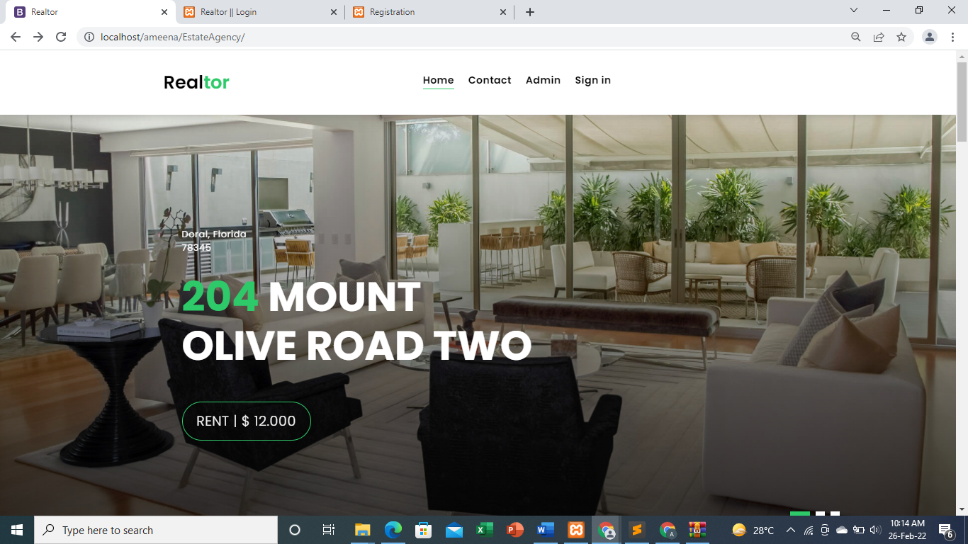

#### Customer Profile page

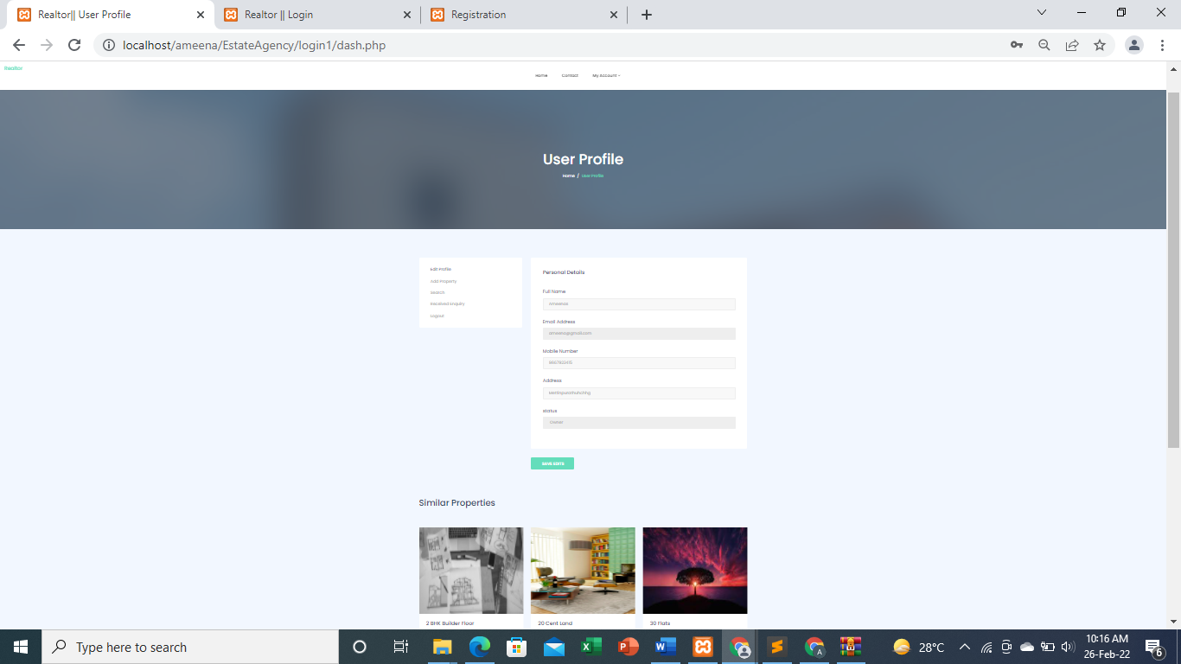

#### Add Property page

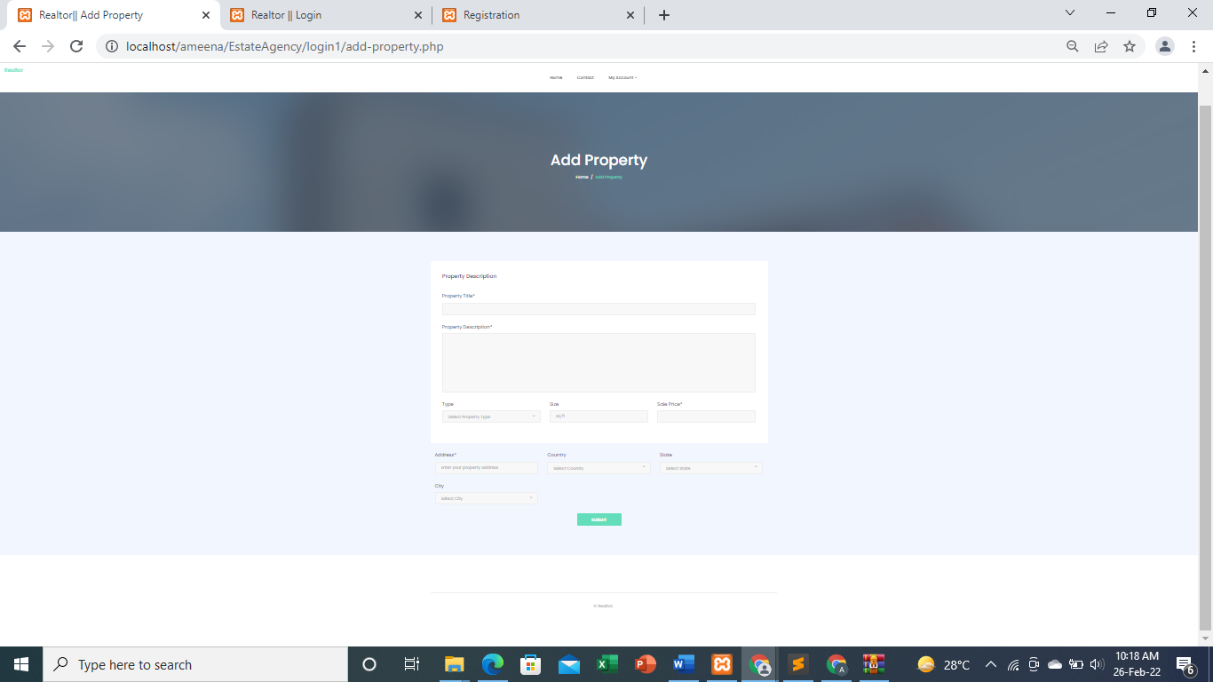

#### Search Property Page

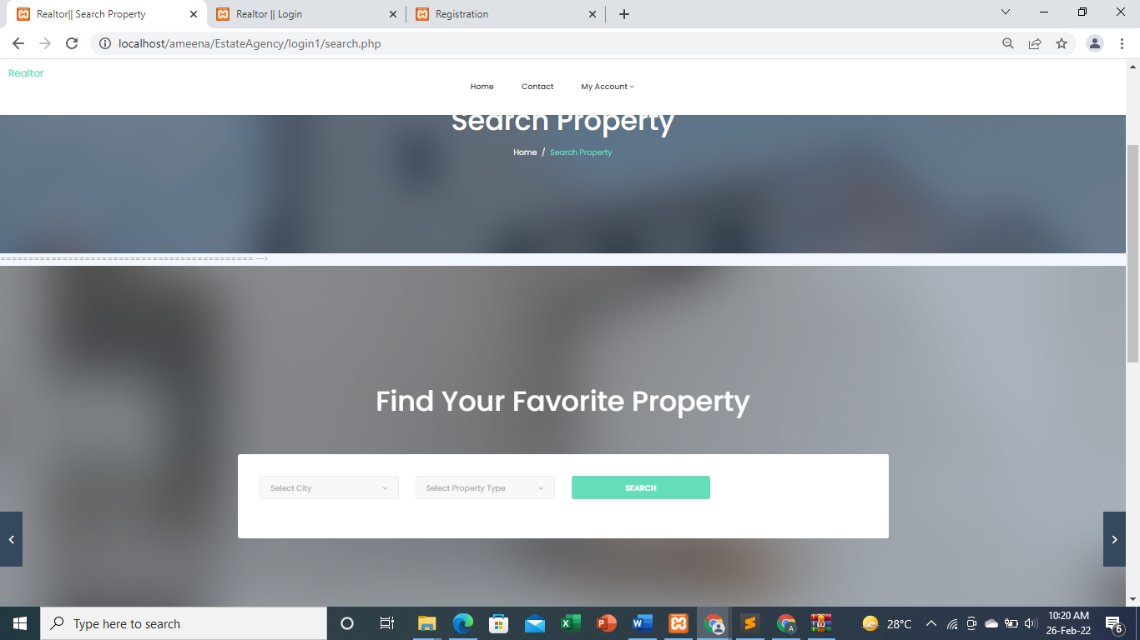

#### View Single Property Page

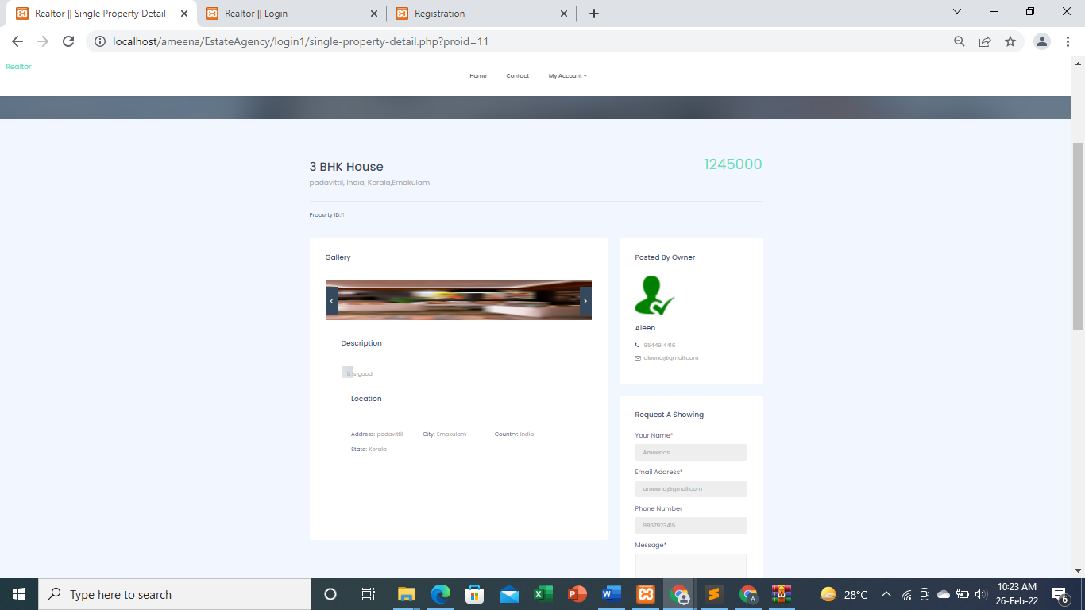

**ADMIN PAGES**

#### Admin Dashboard Page

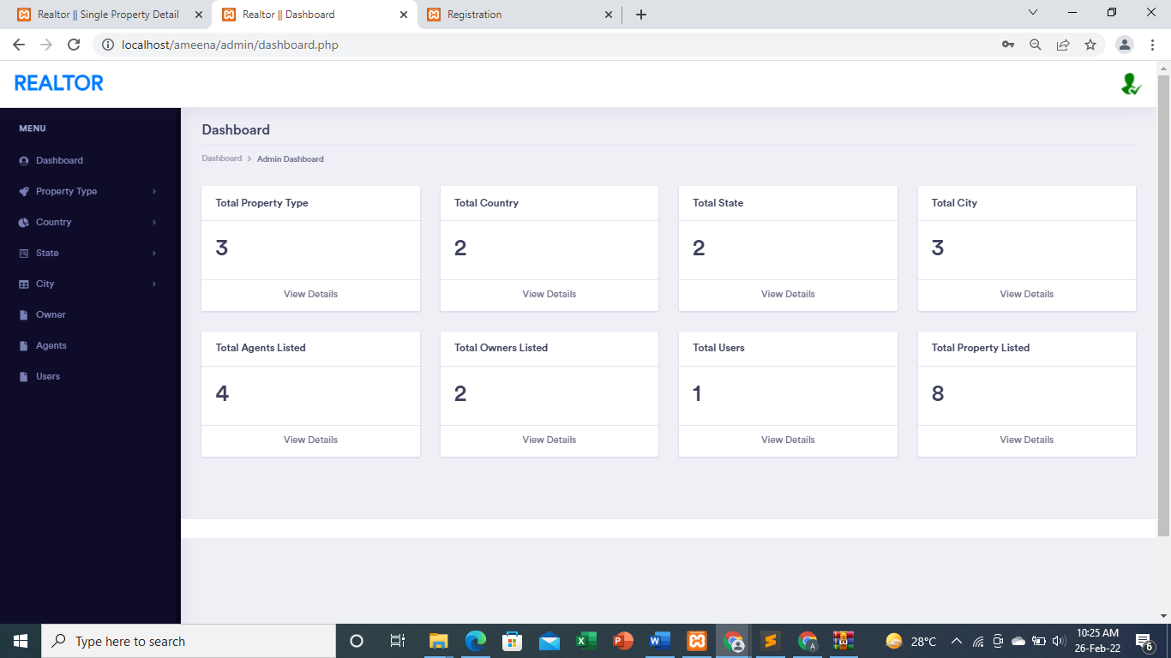

##### Add Property Type

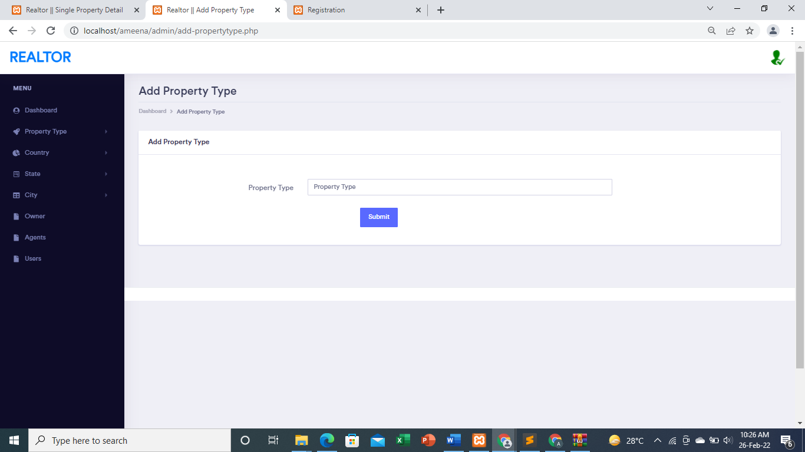

#### Add City Page

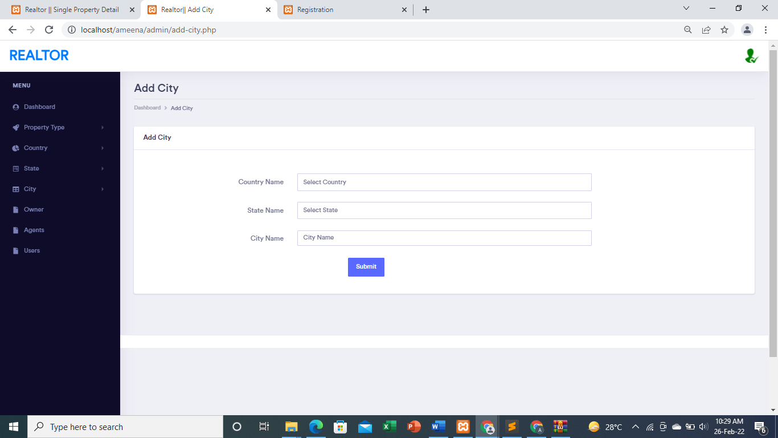

#### View all registered customers

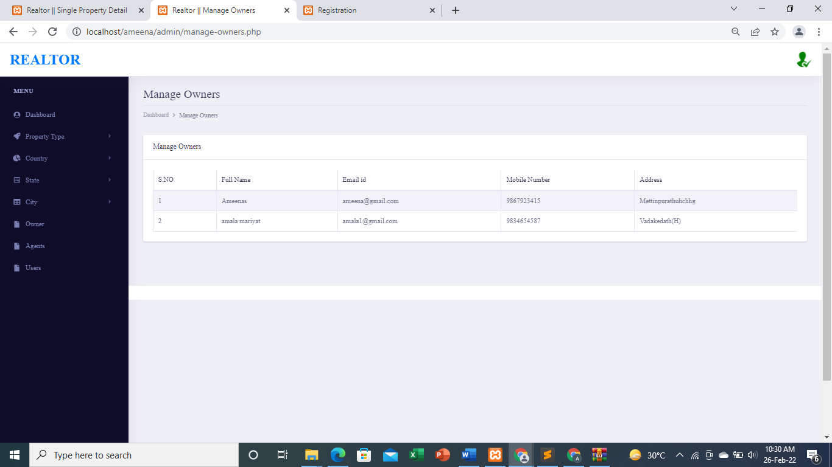

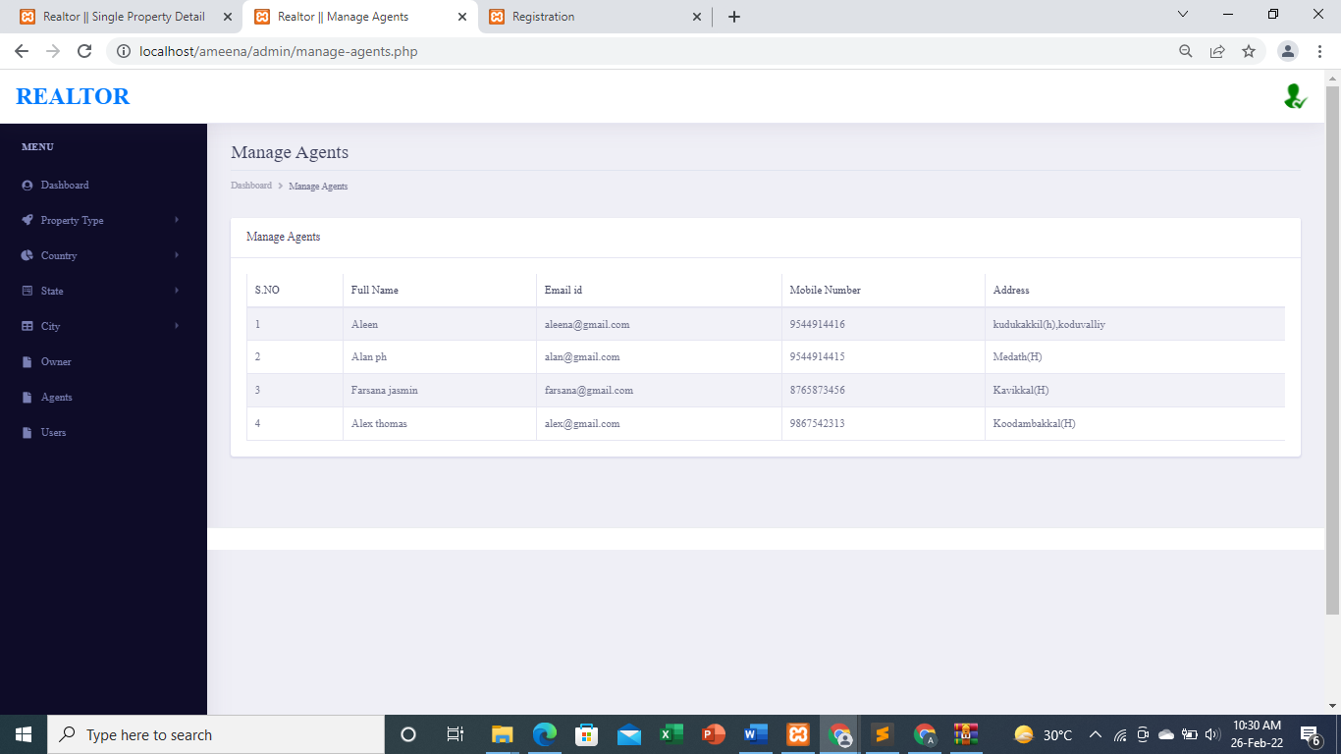

#### View all Property Type

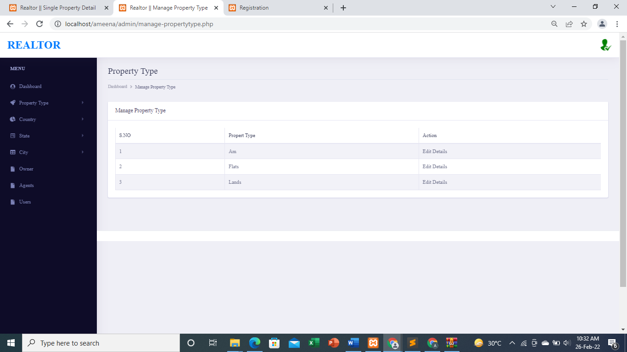

#### View all Cities with state and Country



 